This page is not fully translated, yet. Please help completing the translation.
(remove this paragraph once the translation is finished)

What is the purpose of an e-mail Dumbster?
Dumbster is a Java-based program, which is able to receive e-mails and display them in a panel. The concept behind Dumbster is to have the possibility to test processes and dispatch related e-mails without having to send feigned productive e-mails to participants of a process.

Starting Dumbster

Windows
Dumbster is opened in Windows by double-clicking on the delivered “dumbster.bat” file

Linux
Please use the following command to execute the shell script “dumbster.sh” in Linux:
./dumbster.sh
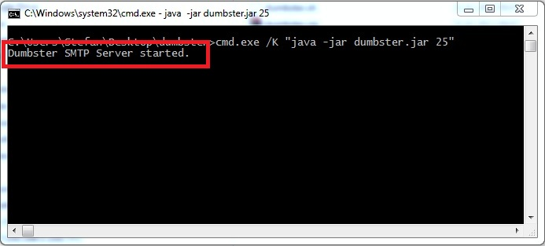
The following window will then open, which confirms the successful start of Dumbster:

Configuring the client profile
For Dumbster to be able to receive e-mails, TIM has to be informed that it will send e-mails to a specially set-up SMTP server and not to a productive e-mail server. For this to be successfully done the corresponding parameters have to be set up in the client profile (please refer to the section on the [en:software:tim:administration_client|Administrator Client]] for further information!).
Dumbster does not require an authentication; however, it is nevertheless capable of processing an authentication if desired!

SMTP host
Normally, Dumbster will be executed on the same server on which TIM is running. Under this condition it is sufficient to add the following value as a SMTPhost:
localhost
If Dumbster is to be used on an external computer, either the correct host name or the IP address of the device must be entered.
If you don't know the IP address or the host name of the computer, please contact the company IT department!

SMTP port
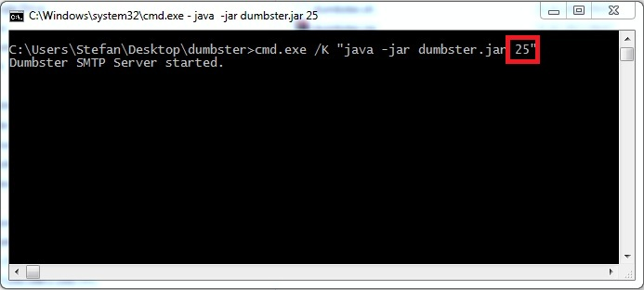
By default, the scripts are set to be started using port 25. To configure this setting, the client_profile must be opened, followed by the the item SMTPhost. The port assigned to Dumbster will be displayed on the panel (which in this case would be port 25)
! Attention firewall
In most companies almost all computers and servers are protected by a firewall against unauthorized access. In such a case please contact your IT department to inquire further details regarding the next steps of configuration. This will not be necessary if Dumbster and TIM are running on the same server and the entry SMTPhost local host is set.

Testing Dumbster
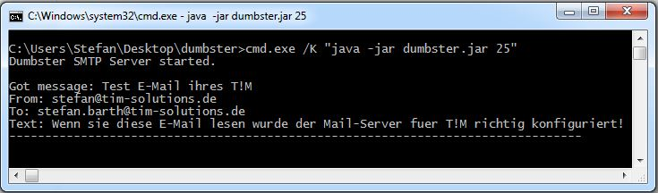
To ensure the correct that e-mails are being correctly received, a test e-mail may be sent to Dumbster. This is performed by clicking on the option for testing an e-mail configuration:

Rendering the readout of Dumbster as a single file
If the readout of Dumbster should be merged into one single file (e.g., several users need to have access to the complete Dumbster readout) then the file dumbster.bat has to be adapted accordingly. This Dumbster file is edited by opening it with a text processing program. The desired file directory for saving the readout has to be chosen.
cmd.exe /K "java -jar dumbster.jar 25" > C:\User\John.Doe\dumbster.log

