User Profile - Absence
If a user is not able to do his/her assigned tasks due being absent from the company, this should be documented in the system. Please refer to rules concerning absence in a user profile for further information.
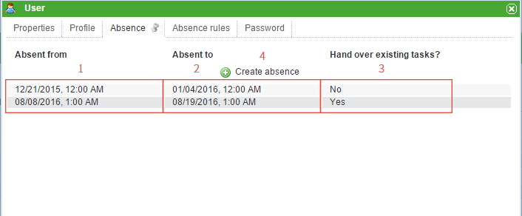
Element | Description
1 | The date on which the absence starts.
2 | The date on which the absence ends.
3 | This options enables the user to transfer assigned tasks to somebody else as a substitute. Please refer to rules concerning absence in a user profile for further details.
4 | This button adds new dates for absence. How to add a date of absence
 | New task mails will be generated by activating the option for transferring tasks to a designated substitute!

How to add a date of absence
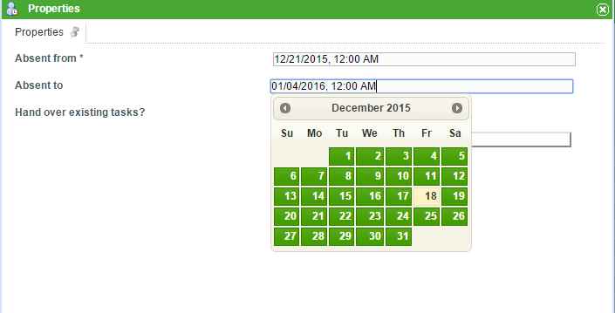
By clicking on the button “Create Absence” the above window appears. Dates can be entered either manually or by selecting them from a calendar, which appears by clicking on the date field. The transferal of tasks to a designated substitute can be selected by checking the corresponding box.

