This page is not fully translated, yet. Please help completing the translation.
(remove this paragraph once the translation is finished)

RSS Feeds with Authentification
For different Clients (z.B. ToDo Client) it is possible to show all task via RSS feed. Therefore you have to click on the symbol and copy the right link. This link can then be added to RSS Reader or Mail Client.
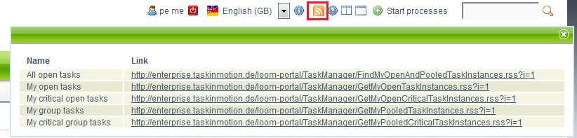

Outlook

1. Adding the feed
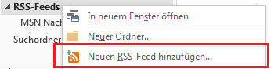
Right Click the menu “RSS Feeds”. Then “Add new RSS Feed” in the opening menu.

2. Register the Link
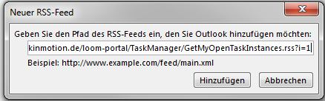
After that a window is opened. Now the copied link from the T!M Client has to be pasted here.

3. Authentification
In order to load the current feed the user credentials are needed. Like in the T!M System you have to enter the client and the username (client/username) and the passwort. Don't forget the Checkbox “Save Password”.
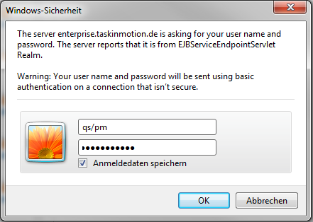

Lotus Notes

1. Adding the feed
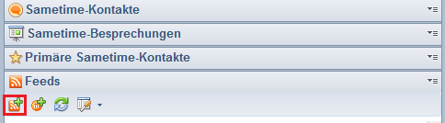
Select “RSS Feeds” on the right side. With the green symbol it is possible to add new feeds.

2. Register the Link
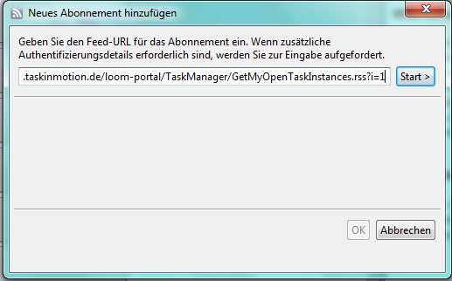
After that a window is opened. Now the copied link from the T!M Client has to be pasted here and the “start” Button has to be clicked.

3. Authentification
In order to load the current feed the user credentials are needed. Like in the T!M System you have to enter the client and the username (client/username) and the passwort. Don't forget the Checkbox “Save Password”.


