Instance Report
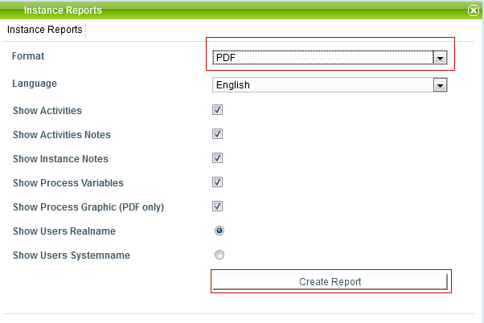
In TIM, instance reports can be displayed and downloaded as PDF-documents. This can be done via the context menu which opens by right-clicking the particular instance.

The following information about a process instance can be viewed in this report:
- name of the process instance
- completed activities
- open activities
- status
- description of the process instance
- smartform
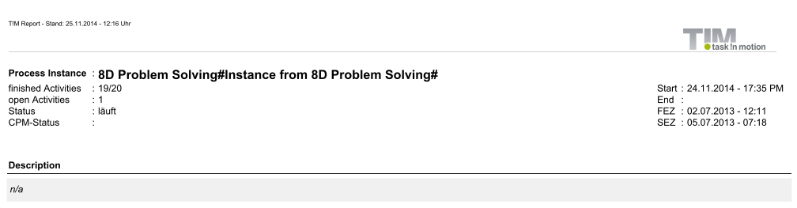

Information about activities:
- start date and start time
- finish date and finish time
- EST / LST / EFT / LFT

Information about tasks:
- name of the task
- person responsible
- description of the task
- start (date / time)
- finish (date / time)
- assignment history (date / time, assigned by, assigned to)

