Group Settings
Preferences for a specific group can be adapted in the group settings window.
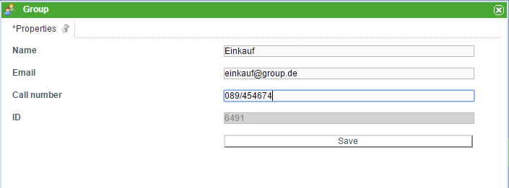
Name | Description
Name | Here, the name/ description of the group can be entered or adapted.
E-Mail | If an e-mail address is given, all e-mails which are addressed to a group and don't have a specific user as the recipient are sent to this address. If no e-mail address is given, an e-mail with a group as the listed recipient is sent to all users within this group.
Telephone Number | Here, a telephone number for this group can be entered. For example, this could be the telephone number of the group appointee.
ID | This field can not be adapted and displays the unique identification number of the existing group.

