Editing Context Roles
Via the administration client, context roles can be added and adapted. Context roles fulfill the task of allotting a specific role to a user within a process.
If a context role is adapted, the following window opens:
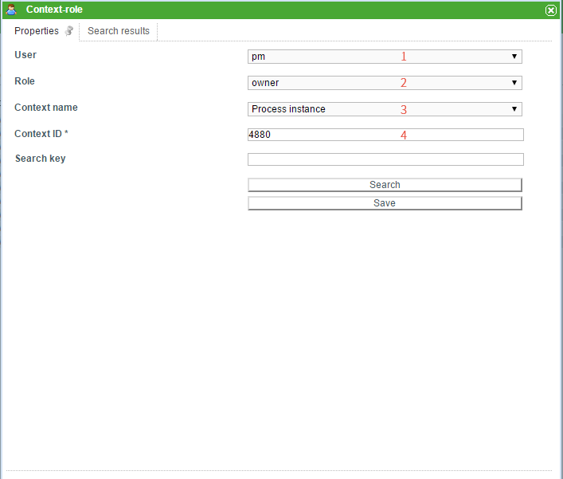
Element | Description
1 | Here, the user for which the role is created is selected. A click on the drop-down menu will open it and all available users will be displayed. The user required can now be chosen.
2 | This drop-down menu is used to select which of the aforementioned roles the user should be assigned to.
3 | Here, the context name is chosen. This is indicative of which frame the context role is located in.
4 | Here, the context-ID, which denotes the definition/instance being designated for this role, is displayed. This field can not be adapted directly, but rather it is filled using the search (Element 5). See search

Search
In order to designate a specific merit to a context role, the search has to be used. For instance, a process instance can be searched for based on the corresponding ID. The drop-down menu Context name is used to indicate if a process definition or a process instance is being searched. The search term should reflect if a process definition or a process instance is searched.
If “process definition” is chosen in the context name, then the name of the wanted process definition has to be entered in the search field.
If “process instance” is chosen, the name of the process instance for which the role is to be valid has to be entered in the search field.
It is also possible to start the search without making an entry. A list of all possible process definition or process instances, in descending order by date, will then be released.
After a successful search, the tab “Search results” will open.
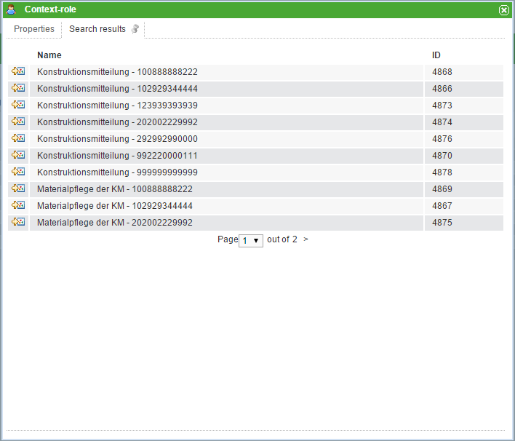
In this list the results corresponding to the search term will appear. Clicking on an element from the list will activate the tab “Properties” and the ID of the chosen selection will be noted in the context-ID field (Element 4).

Follow Context Roles
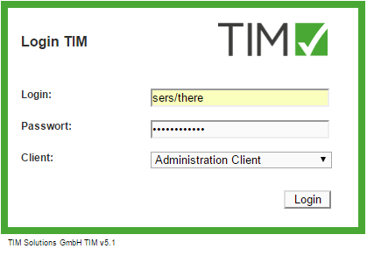
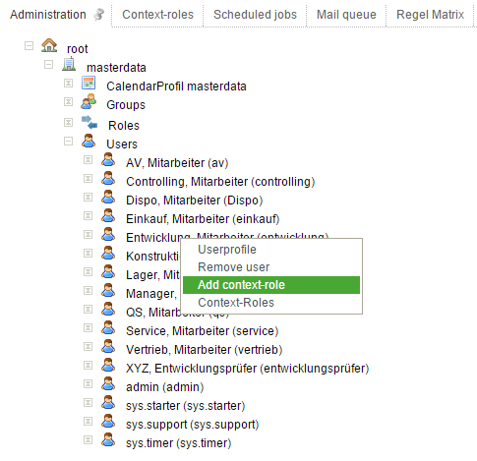
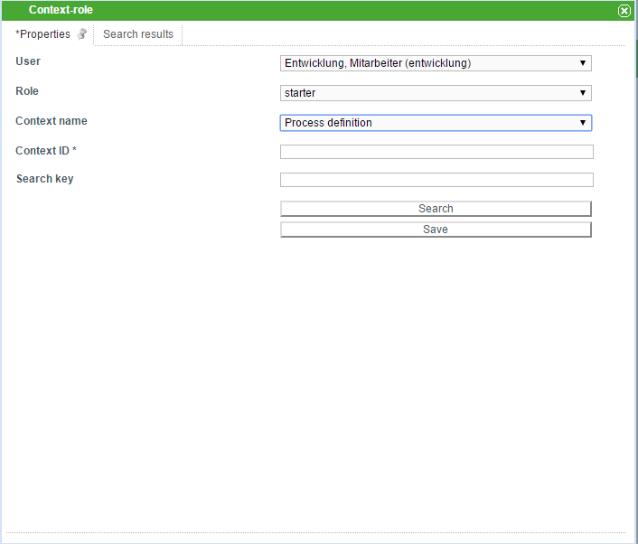
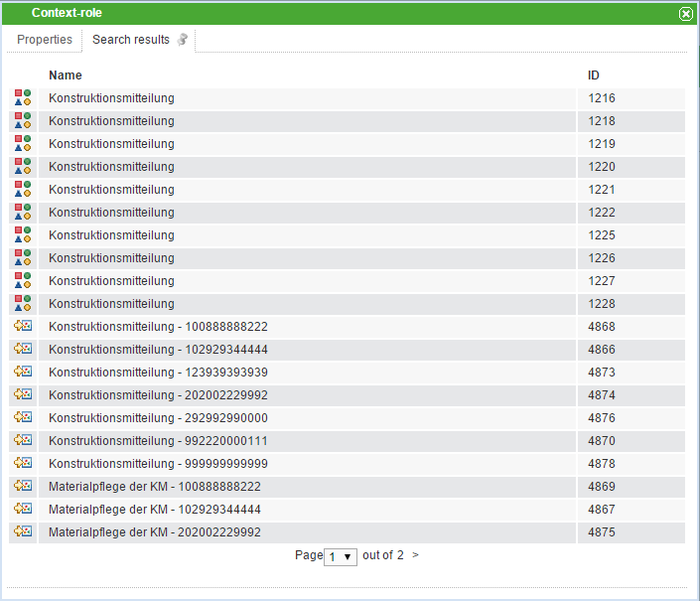
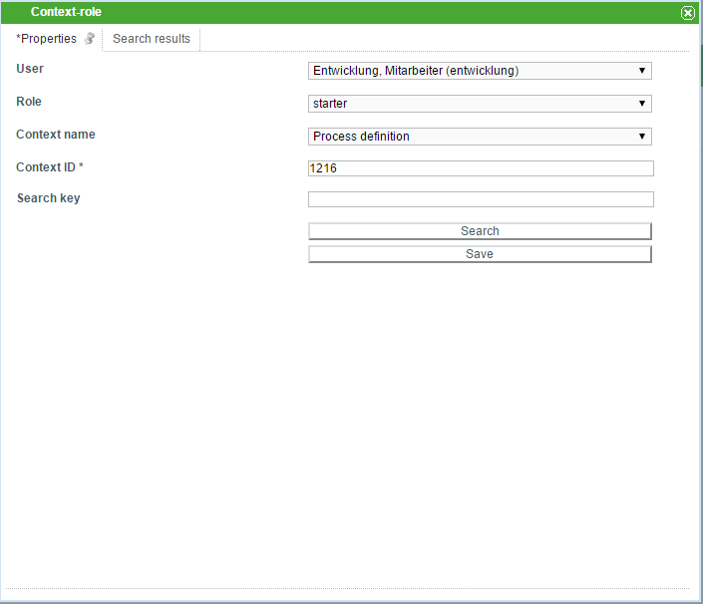
Use the admin user to log-in to the Admin Client.
In the Administration tab, choose the User element. Next, right click on the user being adapted and select Add context role.
In the Context role pop-up, a role (preferably “starter”) is chosen.
For the context name, “process definition” should be chosen.
Enter the beginning of the desired process definition in the field search bar and click on the “search” button.
In the following pop-up, the columns can be rearranged by selecting “ID”. The top entry corresponds to the most recent process definition.
Click on the row with the highest ID from the searched definition.
By clicking on the “save” button, the corresponding context role is updated.

