Configuring Columns
The optical display of the table, which is included in the ToDo-Client (please refer to elements 14 to 26), can be configured. The user may determine which information is relevant and therefore should be depicted. By right-clicking on a tab a context menu that provides access to this configuration utility will appear.
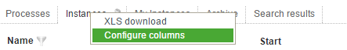

Column view for showing instances
The following columns may be enabled or disabled within a list of instances.
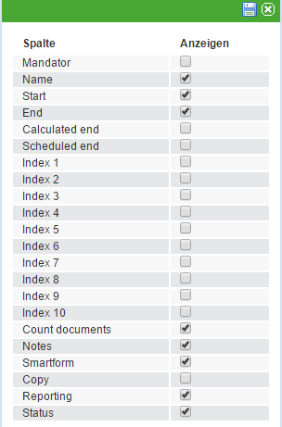
Column | Description
Name | Name of the instance
Start | Start of the instance
End | End of the instance under the condition that it is finished
Index 1 - Index 10 | Additional fields for indices depending on the Smartform. Please refer to Index fields for further information.
Number of documents | This shows a symbol which provides an easy way to uploaded documents and indicates the exact number of documents.
Notes | This shows a symbol which grants access to related notes.
Smartform | This depicts a symbol which opens the proper Smartform in a new window.
Copy | This enables a symbol for copying instances and their respective process variables for employment in a new instance.
Status | This shows a traffic light-symbol, which indicates the current temporal progress of an instance. Please refer to CPM for further details on this topic.

Column view for showing activities
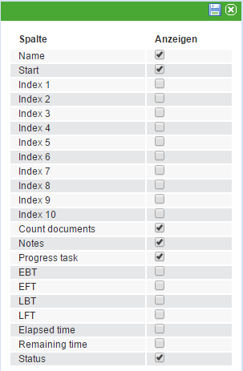
Column | Description
Name | Name of the activity
Start | Start of the instance
Index 1 - Index 10 | Additional fields for indices depending on the Smartform. Please refer to Index fields for further information.
Number of documents | This shows a symbol which provides easy access to uploaded documents and indicates the exact number of documents.
Notes | This shows a symbol which grants access to related notes.
Finished Tasks | This provides and overview of how many tasks belong to this specific activity and how many of these tasks have been finished.
ESP | Earliest starting point. Please refer to Points in time of a task
EEP | Earliest ending point. Please refer to Points in time of a task
LSP | Latest starting point. Please refer to Points in time of a task
LEP | Latest ending point. Please refer to Points in time of a task
Status | This shows a traffic light-symbol, which indicates the current temporal progress of an instance. Please refer to CPM for further details on this topic.

Column view for showing tasks
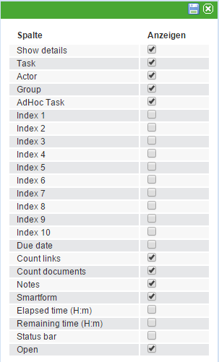
Column | Description
Show details | This enables a symbol that opens a window showing the task-specific properties.
Task | This shows the exact name of the task.
Person responsible | This shows the name of the person responsible for the task provided that this is already known.
Group | This shows the group responsible for managing the task.
AdHoc task | This shows a symbol which indicates if this task has been created AdHoc.
Index 1 - Index 10 | Additional fields for indices depending on the specific Smartform. Please refer to index fields for further information.
Number of links | This symbol enables the user to directly open a window providing an overview of links relevant for the successful completion of the task.
Number of documents | This shows a symbol which provides easy access to uploaded documents and indicates the exact number of documents.
Notes | This shows a symbol which grants access to related notes.
Smartform | This depicts a symbol which opens the proper Smartform in a new window.
Elapsed processing time | This indicates how much time has elapsed since the start of the current task.
Remaining processing time | This indicates how much time is remaining for the successful completion of the task.
Status | This shows a traffic light-symbol, which indicates the current temporal progress of an instance. Please refer to CPM for further details on this topic.

