Emptying the Cache in Internet Explorer 9

Using the Menu Bar
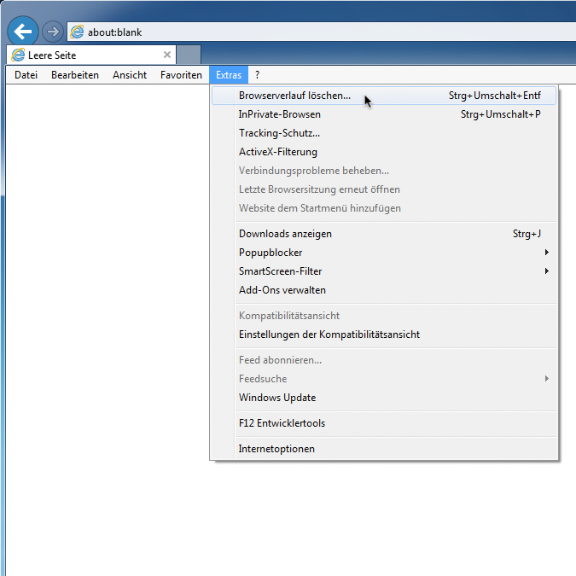
1. Within the Extras menu, click on Delete Browsing History.

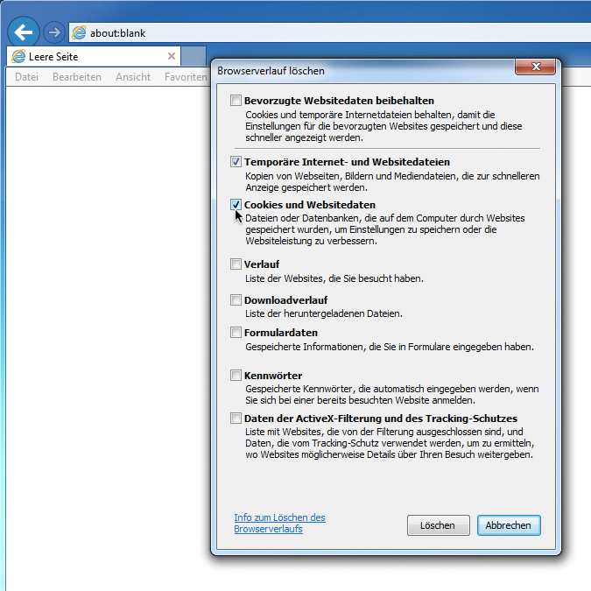
2. Select Temporary internet files and website files as well as Cookies and website data. Preserve Favorites website data should not be selected.

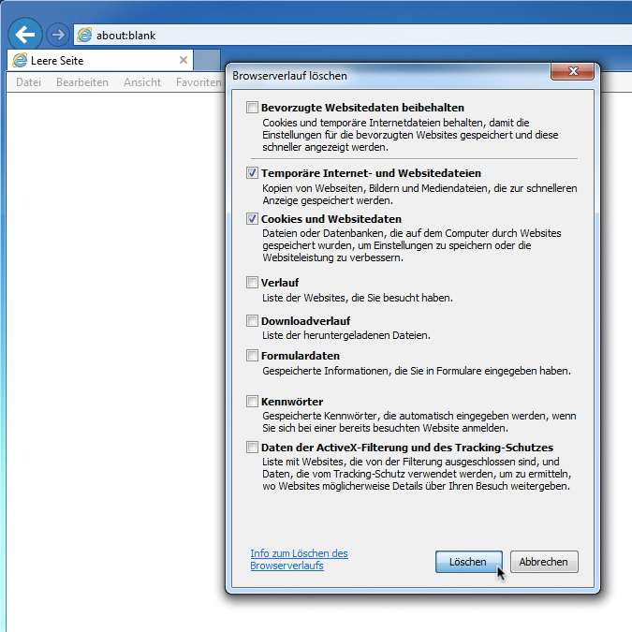
3. Confirm by selecting Delete.

Without using the menu bar
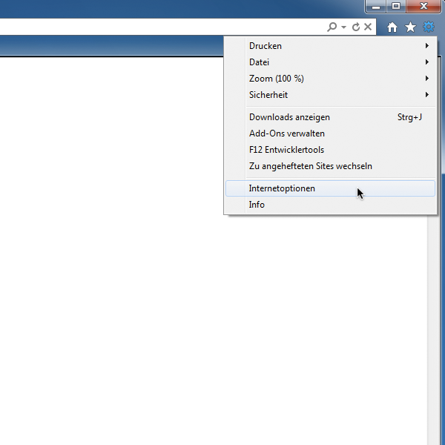
1. Click on the gear symbol and select Internet Options

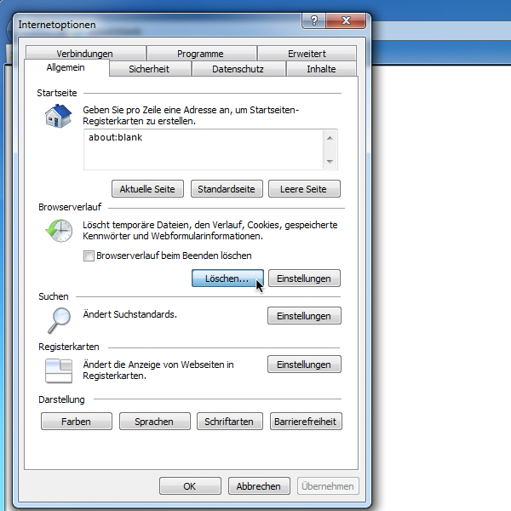
2. Select the tab labeled General, then within the Browser History click on Delete.

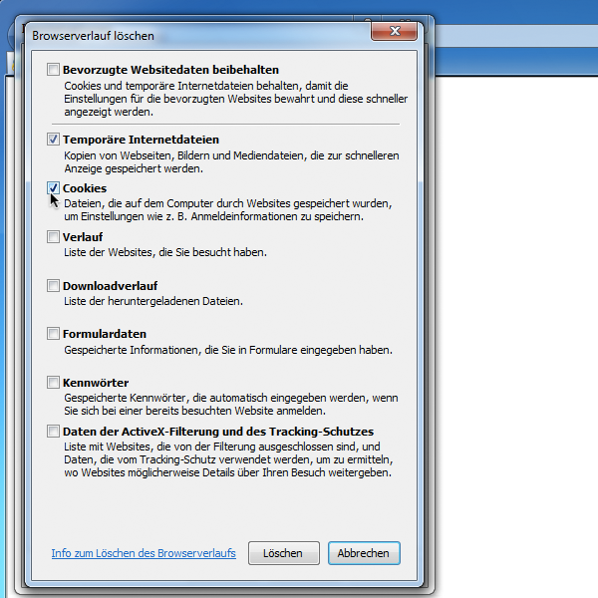
3. Select Temporary internet files as well as Cookies. Preserve Favorites website data should not be selected.

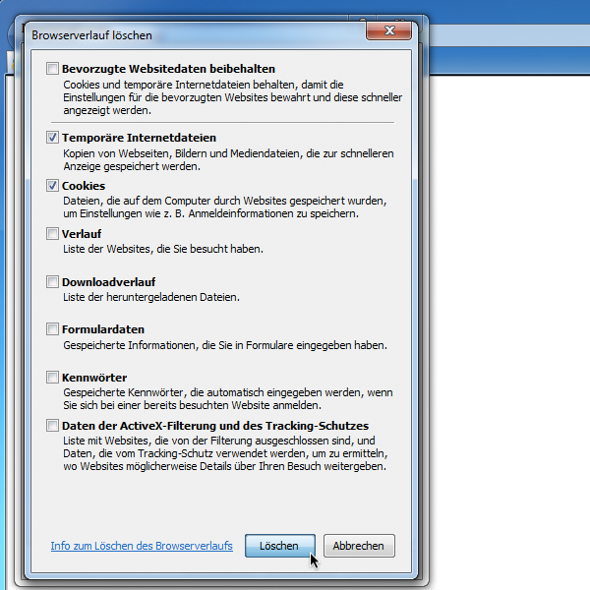
4. Confirm by selecting Delete.

