Emptying the Cache in Mozilla Firefox 29 and higher

Without using the menu bar
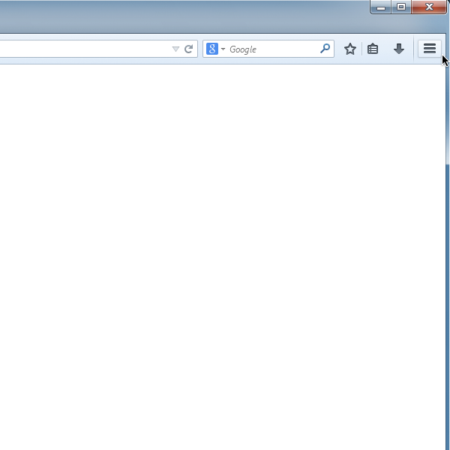
1. Click on the symbol to access the properties menu -- the three bars in the upper-right corner.

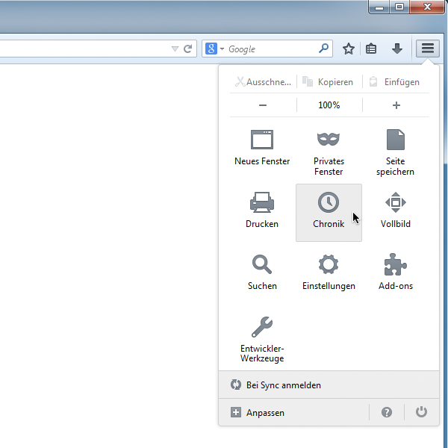
2. Within the overview, select History.

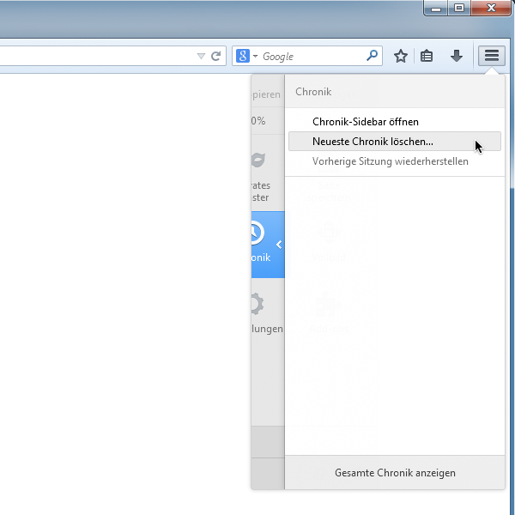
3. Click on the option Clear recent history....

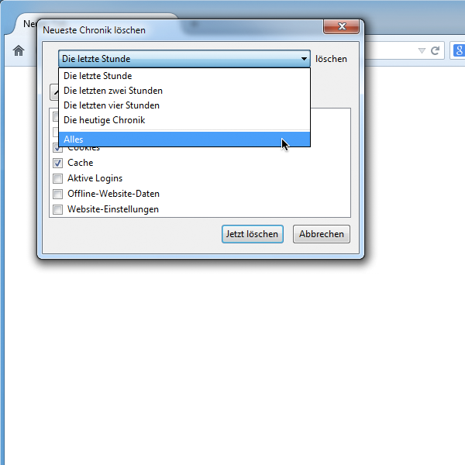
4. Select Everything from the drop-down menu.

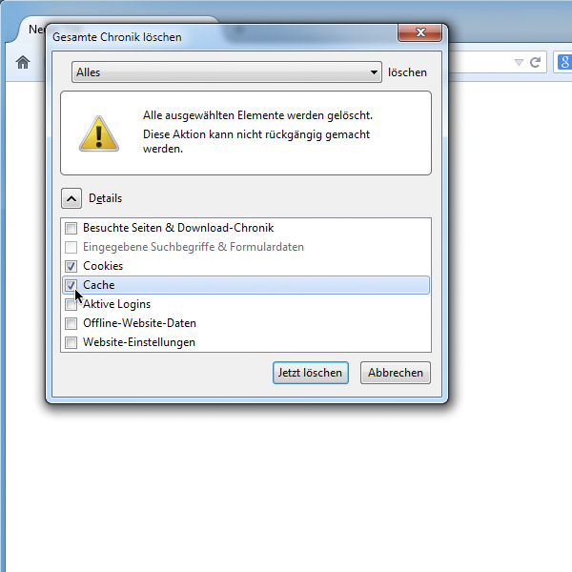
5. Within the Details menu, select Cookies and Cache.

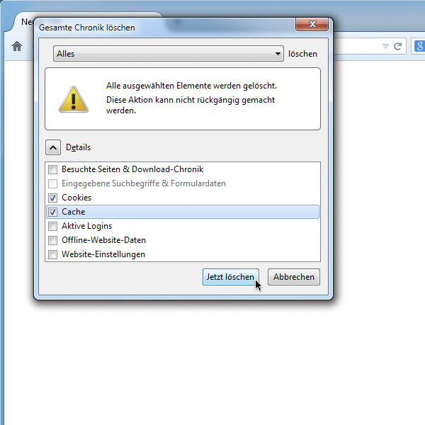
6. Confirm by selecting Clear Now.

Using the menu bar
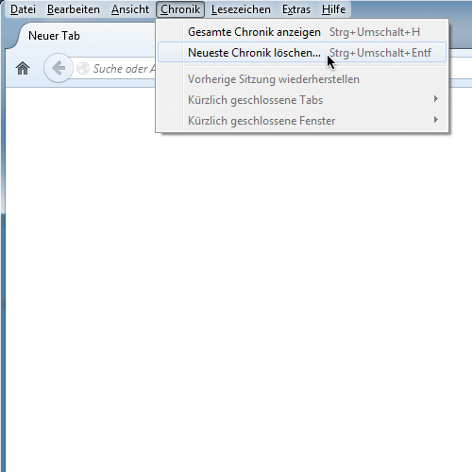
1. Within the History menu, select Clear recent history.

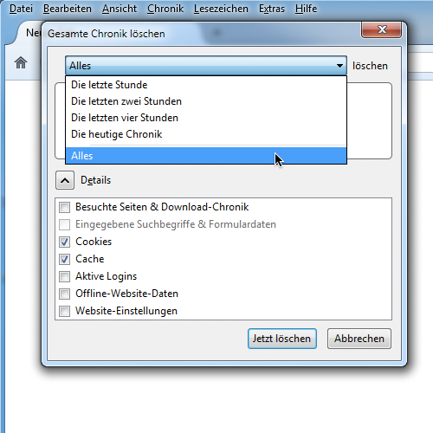
2. Select Everything from the drop-down menu.

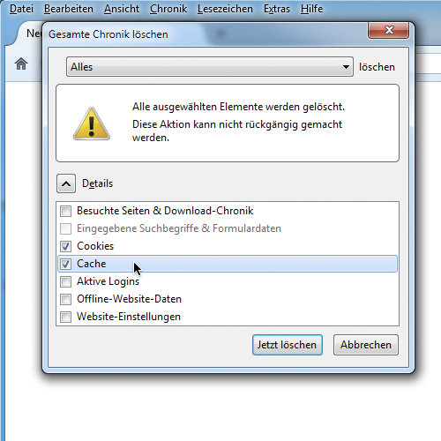
3. Within the Details menu, select Cookies and Cache.

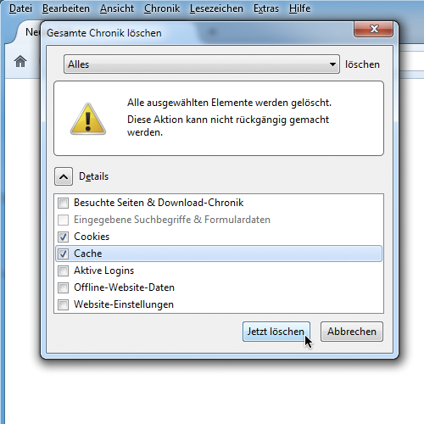
4. Confirm by selecting Clear Now.

