Conditions for an evaluation
Evaluations are defined by SQL-Statements. Therefor only the following predefined dashboard views can be used.

Old Views
If you are still using the old views, they can be looked into here.
 | Please contact the support before the update, because column names change and widgets have to be adjustzed after the update!

Explanation of table contents
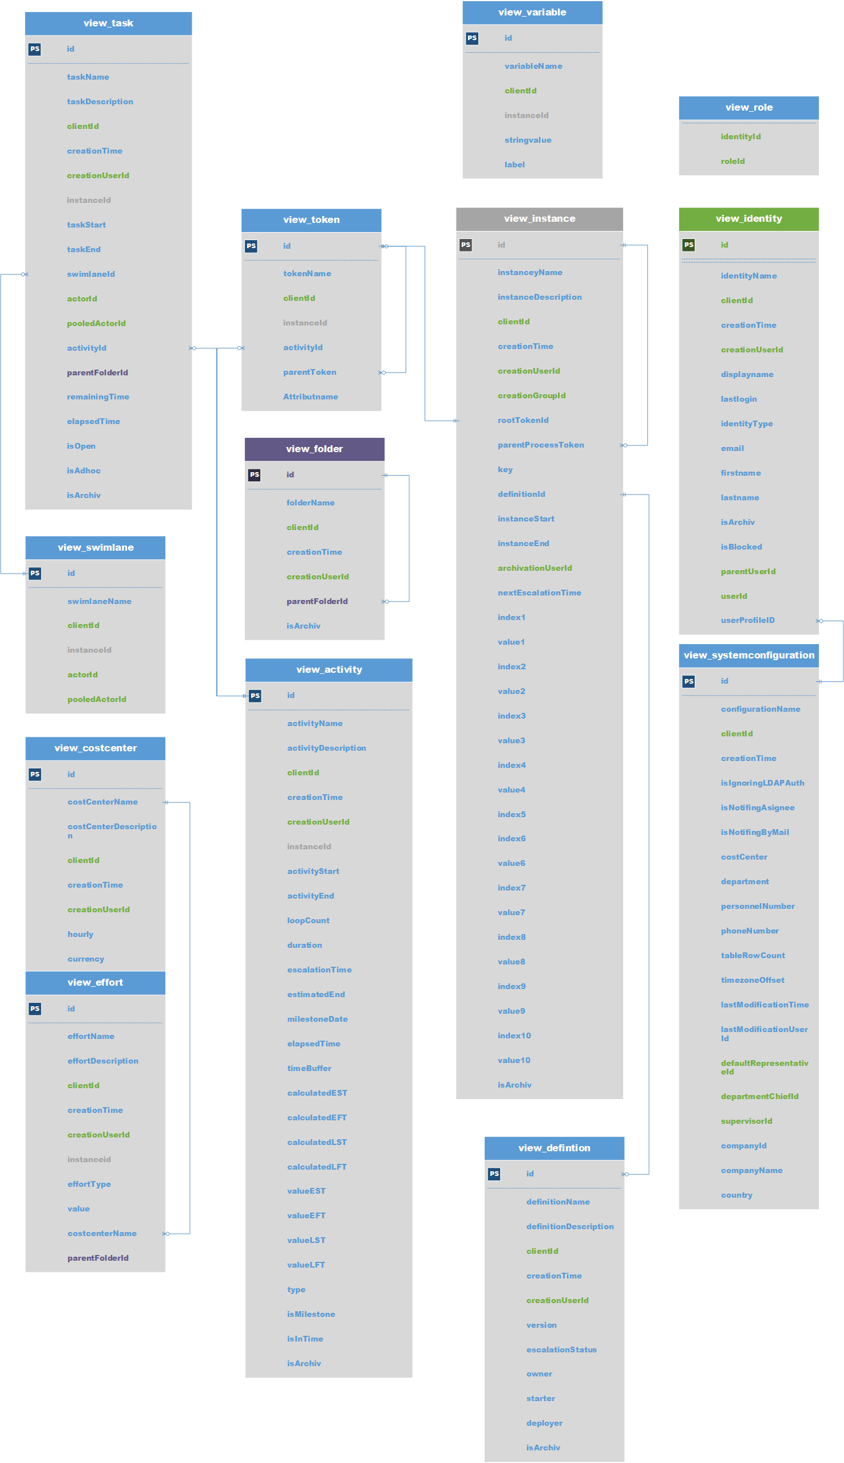
- id contains the so called primary key and is a unique key in the table.
- instanceId contains the primary key of the processinstance that corresponds to this object/entry.
- <placeholder>Namecontains the object's name.
- <placeholder>Descriptioncontains the object's description.
- <placeholder>Start returns the time, when the process became active on this object. A task can e.g. be crated earlier and be started at a later point in time.
- <placeholder>End returns the time, when the process left this object.
- creationTime is the entry's creation time.
- creationUserId contains the primary key (see id) of the user, which created the entry.
- is<Placeholder>contains a true/false value.
- isArchiv indicates, whether the object is already archived or not.
—-
view_activity
- id: The unique identification number used throughout the entire database
- activityName: Name of the activity
- activityDescription: Contains a description of the activity
- clientId: A number referencing a specific client
- creationTime: The exact point in time when the activity was initiated
- creationUserId: A number referencing the impacted user
- instanceId: A number which references an impacted instance in which the activity is active
- activityStart: The exact point in time when this activity was started
- activityEnd: The exact point in time when the activity was finally terminated
- loopCount: If the process runs through the activity repeatedly (loops), the runs are saved here.
- duration: contains the activity's maximum and modelled process time.
- escalationTime: contains the calculated time of the activity's next escalation.
- estimatedEnd: contains the activity's expected end date.
- mileStoneDate: contains the time, when the next milestone should be reached.
- elapsedTime: contains the elapsed time for processing the activity.
- timeBuffer: contains the calculated buffer for this activity.
- calculatedEST: Calculated earliest start time
- calculatedEFT: Calculated earliest finish time
- calculatedLST: Calculated latest start time
- calculatedLFT: Calculated latest finish time
- valueEST: pure time display of earliest start time (contains Business Calender)
- valueEFT: pure time display of earliest finish time (contains Business Calender)
- valueLST: pure time display of latest start time (contains Business Calender)
- valueLFT: pure time display of latest finish time (contains Business Calender)
- activityType: returns type of activity (ScriptNode, Tasknode, Mailnode,…).
- isMilestone: indicates, whether the activity is a milestone or not.
- inTime: indicates, whether the activity is still on schedule or not.

view_definition
- id: The unique identification number used throughout the entire database
- definitionName: The name of the process definition
- definitionDescription: Contains a description of the definition
- clientId: A number referencing a specific client
- creationTime: Point in time at which the process definition was deployed
- creationUserId: The unique ID of the user who deployed the task instance
- version: processdefinition's present version
- escalationStatus: statement about the process' escalation status
- owner: process owner (or group)
- starter: User or group, who is allowed to start the definition.
- deployer: User or group, who is allowed to deploy the definition.
- isArchiv: indicates, whether the definition is already archived or not.

view_effort
- id: The unique identification number used throughout the entire database
- effortName: The name assigned to the effort
- effortDescription
- clientId: The number corresponding to the impacted client
- creationTime: The point in time at which this effort was made
- creationUserId: The unique ID of the user who is responsible for causing the effort
- instanceId: The number corresponding to the impacted instance
- effortType: type of effort (time or money)
- effortValue: value of effort without unit
- timeValue: contains the time effort.
- financeValue contains the financial effort and the cost center's consideration in the moment of capture.
- costcenterName: contains the cost center, on which the effort was booked.
- currency: contains the currency, with which the effort was booked, in the moment of capture.
- hourlyRate contains the cost center's hourly pay in the moment of capture.
- parentFolderId: contains the corresponding folder's primary key.

view_identity
- id: The unique identification number used throughout the entire database
- identityName: Contains the name if the identity
- clientId: A number corresponding to the client at hand
- creationTime: The point in time when this identity/user was created
- creationUserId: The number corresponding to of the user who created this user/group/client
- displayName: contains the full name and username (e.g. Max Mustermann (M.Muster)).
- lastLogin: contains the time, when the user last logged in.
- loginCount: contains the user's number of logins.
- identityType: user's type of identity, can have following values: 'USER', 'GROUP', 'MEMBERSHIP' or 'CLIENT'
- email: user's or group's email-address
- firstname: user's first name
- lastname: user's last name
- parentUserId: contains primary key, that points to the group, which belongs to this membership.
- userID : contains primary key, that points to the user, which belongs to this membership (only affects identityType 'MEMBERSHIP').
- userProfileId: contains the primary key that contains the userprofile.
- isBlocked: indicates whether this user/group/client is blocked or not
- isArchiv: indicates whether this user/group/client is archived or not

view_instance
- id: The unique identification number used throughout the entire database
- instanceName: The name of the process instance
- instanceDescription: Contains a description of the instance
- clientId: A number affiliated with client of the process instance
- creationTime: The point in time at which the process instance was started
- creationUserId: A number corresponding to the user who started this process instance
- creationGroupId :contains the primary key of the group that started the process
- rootTokenId: contains the primary key of the current token, that points to the current activity.
- parentProcessToken: contains the primary key tha points to the corresponding main process.
- instanceKey: contains the created value of the YearIDGenerator, if it was used.
- definitionId: contains a number that points to a processdefinition, which underlies this instance.
- definitionName: the underlying processdefinition's name
- instanceStart: This is the exact point in time when the process instance was started
- instanceEnd: This is the exact point in time when the process instance was terminated
- archivationUserId : contains the primary key that points to the user, which archived this instance.
- archivationTime: point in time, where the processinstance was archived
- nextEscalationTime: contains the calculated time of the process' next escalation.
- index1-10 und value1-10: Aall indexnames and values which were labeled as indexvalues in the process.
- isArchiv: statement whether the processinstance is already archived or not

view_swimlane
- id:The unique identification number used throughout the entire database
- swimlaneName: name of the swimlane
- clientId: A number corresponding to the client at hand
- instanceId: contains the primary key which points to the corresponding instance.
- actorId: contains the primary key that points to the current corresponding user.
- pooledActorId: contains the primary key that points to the corresponding group

view_task
- id: The unique identification number used throughout the entire database
- taskName:Name of the task
- taskDescription: Contains a description of the task
- clientId: A number referencing a specific client
- creationTime: The exact point in time when the task was initiated
- creationUserId: A number referencing the impacted user
- instanceId: A number which references an impacted instance in which the task is active
- taskStart: The exact point in time when this task was started
- taskEnd: The exact point in time when the task was finally terminated
- actorId:contains the primary key that points to the current corresponding user.
- pooledActorId: contains the primary key that points to the current corresponding group.
- activityId: contains the primary key that points to the superordinate activity.
- parentFolderId: contains the corresponding folder's primary key.
- swimlaneId: contains the primary key that points to the swimlane, in which the task lies.
- remainingTime:contains the remaining time for processing the activity.
- elapsedTime: contains the elapsed time for processing the activity.
- isOpen: indicates whether the task is finished or not (Attention! Signal-Methods often do not finish tasks!)
- isAdhoc: indicates whether this task was created as an [en[:software:tim:ad_hoc_tasks|AdHoc task]] or not
- isArchiv:

view_token
- id: The unique identification number used throughout the entire database
- tokenName: The name of the token
- clientId: A number referencing a specific client
- instanceId: contains the primary key which points to the corresponding instance.
- activityId: contains the primary key which points to the corresponding activity.
- parentTokenId: contains the primary key which points to a sub-token. If the Roottoken is on a closing AND gateway, a sub-token is found for each entry/exit

view_variable
- id: The unique identification number used throughout the entire database
- variableName: Name of the instance variable
- clientId: A number referencing a specific client
- instanceId: contains a number which points to the corresponding instance
- stringValue: contains the processvariable's content
- label: contains the processvariable's corresponding label

view_role
- identityId: contains the primary key that points to the current corresponding user.
- roleId: contains the primary key that points to the current corresponding role.

view_costcenter
- id: The unique identification number used throughout the entire database
- costcenterName: Name of the cost center
- costcenterDescription: Contains a description of the costcenter
- clientId: A number referencing a specific client
- creationTime: The exact point in time when the cost center was initiated
- creationUserId: A number referencing the user who created the cost center
- hourly: contains the cost center's hourly pay
- currency: contains the cost center's currency

view_systemconfiguration
- id: The unique identification number used throughout the entire database
- configurationName:The name of the configuration
- clientId: A number corresponding to the impacted client
- creationTime: Contains the creation time of the configuration
- costCenter : user's cost center from the userprofil
- department: user's department from theuserprofil
- personnelNumber : user's personnel number from the userprofil
- phoneNumber : user's telephone number from the userprofil
- tableRowCount : field “Display table rows” from the userprofil
- timezoneOffset : user's timezone
- lastModificationTime: contains the time, when the profile was last edited.
- lastModificationUserId: contains the primary key of the user that last edited the profile.
- defaultRepresentativeId : contains the primary key of the user that is lodged as the representative in the userprofil
- departmentChiefId: contains the primary key of the user that is lodged as the department chief in the userprofil
- supervisorId : contains the primary key of the user that is lodged as the supervisor in the userprofil
- companyId : field “Company ID” from the userprofil
- companyName: field “Company Name” from the userprofil
- country: field “Country” from the userprofil
- isNotifingByMail: field “Email-Notification preferred” from the userprofil or from the clientprofil
- isNotifingAsignee: field “Notify asignee if his task is done by somebody else” from the userprofil
- isIgnoringLDAPAuth: field “ignore LDAP authentication” from the userprofil

view_folder
- id: The unique identification number used throughout the entire database
- folderName: Name of the folder
- clientId: A number referencing a specific client
- creationTime: Contains the creation time of the folder
- creationUserId: A number referencing the creater
- parentFolderId: contains a primary key that points to itself and presents a subfolder in the documents
- isArchiv: Shows wether the folder is archived

