Exporting and updating users
A variety of users may be easily exported as an Excel-file using the Admin-Client. Then, the group assignments as well as roles and rights of the users may be modified. Additionally, new groups and roles may be created.
----

The Excel-file
The Excel-file is the key to exporting or modifying users. The Excel file can be either self-produced or be downloaded in the Admin-Client using the client profile. This is done by opening the context menu from the client-profile-icon via right-click and selecting the menu item Export user (see. Screenshot).
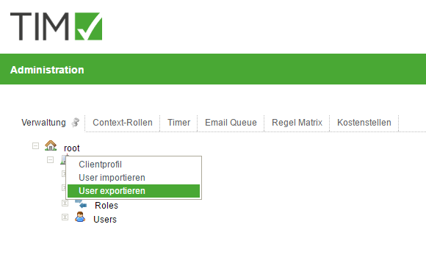

As seen in the linked Screenshot, the users are listed in in column A. The additional columns contain the roles (i.e. member and process manager) as well as the created groups. An x in the appropriate column is used to denote if a user has assumed a role, or similarly if he is a member of a group.
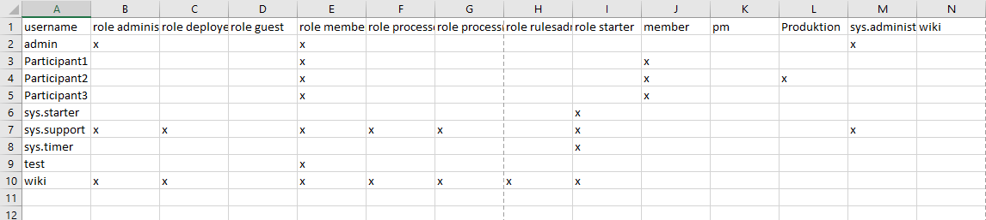 ----

Updating role- and group assignments
In order to assign a role or a group to a user, an x is places in the appropriate column. Similarly, by removing the x from he column, the role or membership of a user within a group is removed. Should the Excel file then be integrated into TIM, the user data will be updated accordingly.

Creating Groups
The excel file can be used to create new groups in TIM. In order to do this, create a column wit the desired group name in the Excel table. (s. Screenshot). 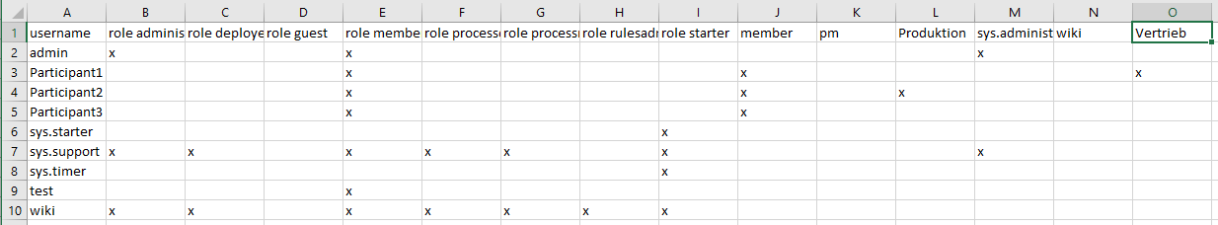

Importing Excel files
By right-clicking on the client icon in the Admin-Client, the Excel file will once again be imported. The menu option import user opens the import pop-up, which then gives the user the option to test document and upload document. Testing the Excel file shows which changes will be made. This may be used to avoid unwanted updates.


