This page is not fully translated, yet. Please help completing the translation.
(remove this paragraph once the translation is finished)

User profile
The user profile is accessible in two ways:
- The user clicks within an open Client on his name in the right-hand upper corner
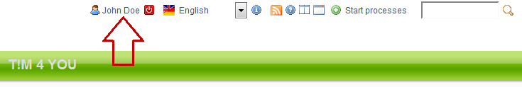
- The administrator clicks on an user Administration Client
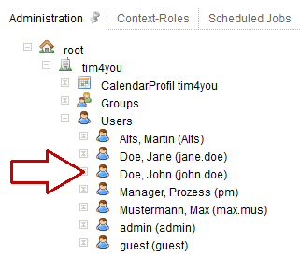
The settings for this user can now be changed in the open user profile.

Within the user profile four different tabs can be chosen according to requirements
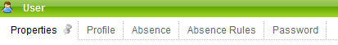
- Properties
- Profile
- Absence
- Absence Rules
- Password

