General
In T!M, there are 4 different clients which users can register for. The rights of single users steers the permission of access to the individual clients. In the bottom part the two ToDo-clients are dealt with, along with a detailed description of individual elements. > The two ToDo-clients require the rights “member”.

Overview ToDo-client
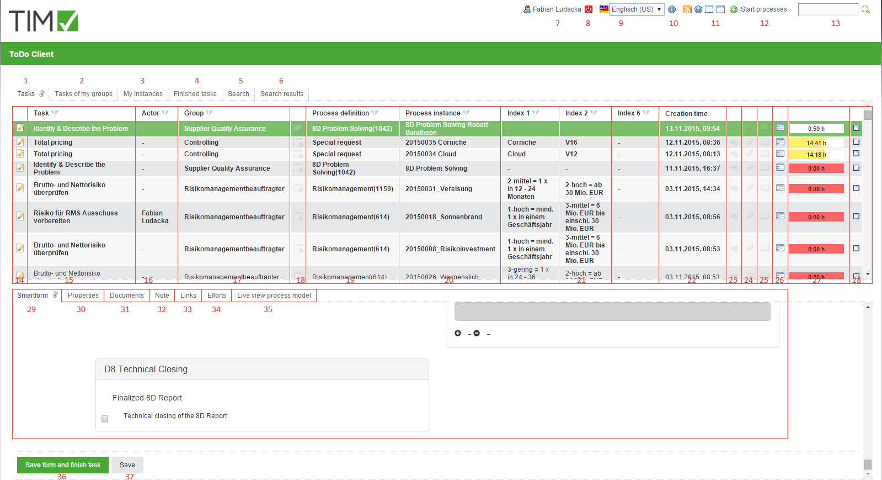

Overview elements
element | description
1 | In this column, all tasks , which are assigned to the current user and his groups without an already assigned actor, can be looked into.
2 | In this column, all tasks which have been assigned to the current user or one of his groups, can be looked into. Here, tasks are displayed to which an actor has already been assigned to and which are in the same group.
3 | In this column, all instances which have been initiated by the current user can be looked into.
4 | In this column, all tasks which have been finished by the current user and have not yet been archived, can be looked into.>> From version v.3.4.7 archived tasks are displayed, too. In client-profile it can be configurated, if finished tasks of my group are to be displayed.
5 | In this column you can, via the smartform, look for process-variables according to process-definitions with the required parameters. The results are displayed in the column search results (element 6). See search >> Attention! Does not work in ToDo-client 1G
6 | In this tab the instances, in which the search (see element 13 and element 5 ) has found the according process-variables, are displayed.
7 | Via a click on the user you get to the user settings in which the own user profile can be adjusted. See user-profile
8 | Here, the current user can can be logged off.
9 | Here, the requested language can be chosen via a drop-down.
10 | Here, the current T!M version and revision can be looked into. The latter is decisive for the support, if an error has occured.
11 | Via the symbols you can switch between the ToDo-Client 1G and the ToDo-Client.
12 | Here, the process-instances can be initiated, provided the current user has the according roles in T!M and is stored as an initiator in the process.
13 | Here you can search for texts/numbers in all processes (in all process-definitions and their process-instances). Relevant data here is the definition name, the instance name and the process-variables. Fitting results are displayed in the search result (element 6).
14 | Via a click on this symbol you get to the property menu of the respective task in which additional information is gathered and various settings can be made.
15 | In this column the name/description of the task is displayed.
16 | In this column, the current arranger, who is responsible for this task, is registered.
17 | If the task is assigned to a group it will be displayed in this column.
18 | This symbol indicates whether or not the task is an AdHoc task and if so, the symbol will be high-lighted with colour.
19 | This column shows the information which process-instance the task belongs to.
20 | This column shows the process-instance's name.
21 | This column contains index fields that can be occupied specifically for a process.
22 | This column shows the creation time of the task.
23 | Via this symbol the menu is directly opened in which the links, which have been assigned to the task, are displayed.
24 | Via this symbol the menu is directly opened in which documents can be uploaded or already uploaded documents can be looked into.
25 | Via this symbol the menu is directly opened in which notes can be added or already added notes can be looked into.
26 | Via this symbol the smartform of the according process is opened directly in a separate window.
27 | The time indicates how much time remains until the task has to be finished. Required for this display is a registered process-time.
28 | Here you can, after the completion of the task, mark it as finished. After the activation there will, again, come a confirmation prompt. By holding the control key it is possible to tick of multiple task simultaneously.
29 | If a process-instance is selected, the according Smartform appears here and can be edited, before the task is to be marked as finished. See Smartform.
30 - 34 | See properties of a task
35 | Here, having selected a task, a model of the current process will appear. The activity in which the process is currently involved is marked. Therefore, it is possible to gain an overview over the progress of the process.
36 | Via this button the processed smartform is saved and at the same time the task is marked as finished. Therefore, it does not have to be ticked of in the list.
37 | Via this button only the changes of the smartform are saved, the task will not be marked as finished and remains active.

Search
If the tab “search” is activated, it is necessary to first chose a process definition from the list or click on the binoculars symbol. After this is done, the according and empty smartform will open. Now the wanted merit has to be entered into the desired field. If the search is carried out via the button “submit search”, all process-instances of the according definition are searched and instances, in which the merit of the process-variables match the the searched, are displayed in the tab “search result”.
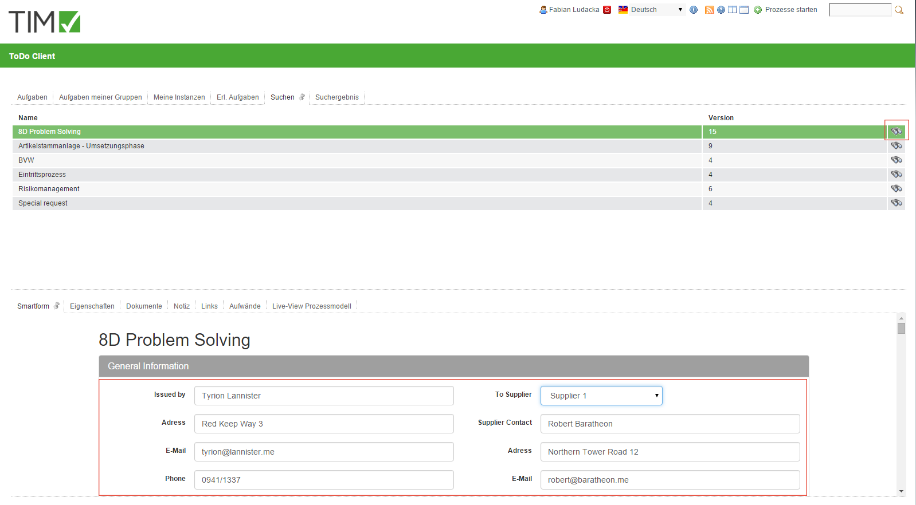suchesf.jpg

