Description
This timer calculates the status light (CPM status) for the entire client. It was built for performance reasons starting with Version 3.6.

Timer Name
any name

Webservice Name
CPMCalculator

Webservice Method
updateEscalationStatus

Example
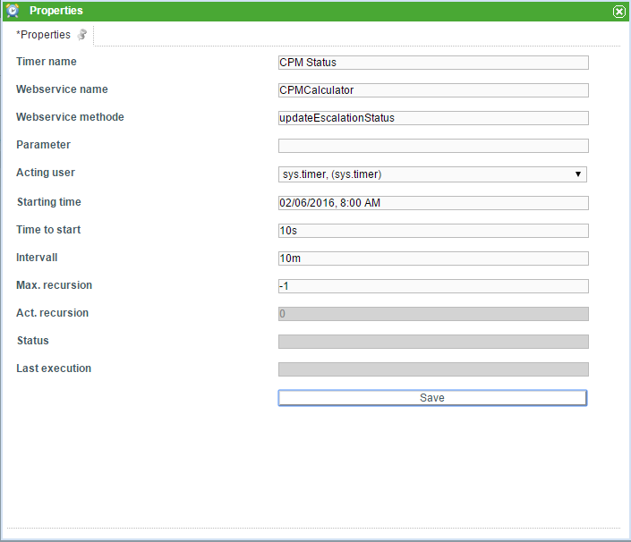

Dependencies
TIM Version : v3.6

