This page is not fully translated, yet. Please help completing the translation.
(remove this paragraph once the translation is finished)

createProcessInstancesByHandler

Description
The timer gets all *.csv files from a folder passed to it and creates for each CSV a new table in the database.
The tables are named as follows: “custom_FILENAME”.
The first row of the CSV determines the number and names of the columns, all other rows fill these columns.
If the number of columns from a row do not correspond to the number of columns of the table, it will filled with “zero” until the number is correct.

Timer Name
any name

Webservice Name
ProcessInstanceManager

Webservice Methode
createProcessInstancesByHandler

Parameter

Parameter
Path to the folder where the CSV files are located!
com.dooris.bpm.actionhandler.CreateAndFillDbByCsvInputHandler,FILEPATH

Example
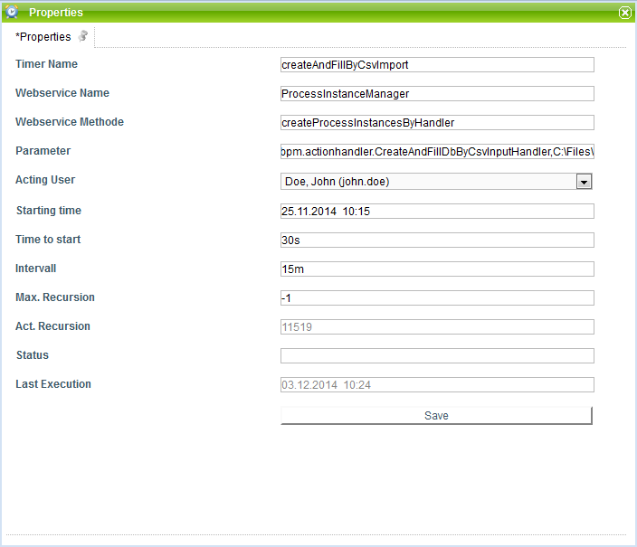

Dependences
T!M Version : Customer_Others

