This page is not fully translated, yet. Please help completing the translation.
(remove this paragraph once the translation is finished)

Tasks
A task is the subunit of an activity. Each activity is made up of one or more tasks. See also Structure of a process. An activity is completed only, when all contained tasks have been completed.
A task is a correct work step that must be executed by an employee before the next process step can be started.
The task assignment determines, who has to do the task.
Tasks have a name, a description, if required a direct Assignment, and can contain Links.
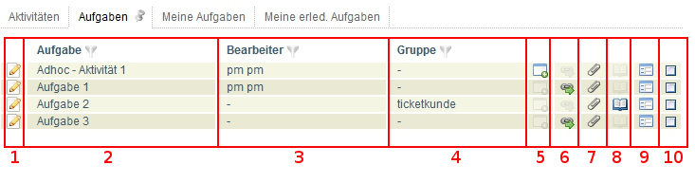
<100% 200px>
Element | Description
1 | Direct access to the Properties of a task is possible with this symbol.
2 | This column contains the name of the task.
3 | This column contains the editor of the task, if one has been assigned.
4 | This column contains the working group of the task, if one has been entered.
5 | The symbol in this column indicates whether the task is an task which was created AdHoc.
6 | This shows if Links are available and if it is so (symbol is filled with color) the overview window of the links can be viewed directly.
7 | This shows if Documents are stored for the task and if it is so (symbol is filled with color) the overview window of the documents can be viewed directly.
8 | This shows if Notes are stored for the task and if it is so (symbol is filled with color) the overview window of the notes can be viewed directly.
9 | With this symbol the Smartform can be opend in a seperate window.
10 | With this checkbox tasks can be finished.

