Mailnode

Process variables
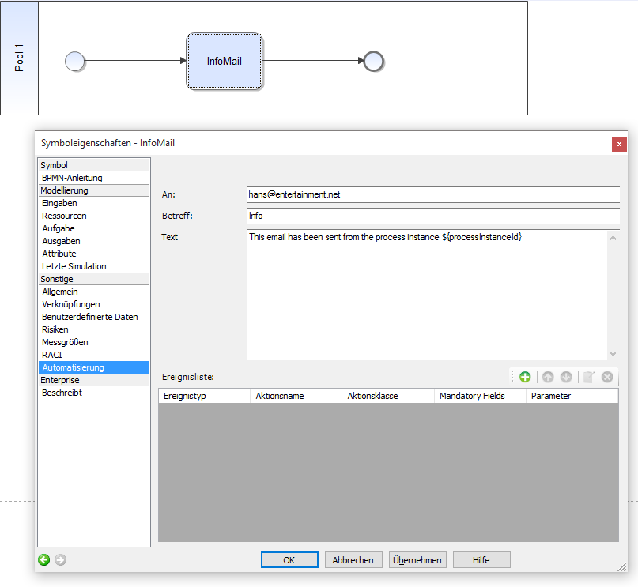
In every mailnode, process_variables can be used to integrate information from the smartform into the mail. For this purpose, the following syntax must be used:
${nameOfTheProcessVariable}
In context, the text of a mailnode could look like this:

HTML mails
The text must be masked in order to send HTML mails. For this purpose, the text must be in included in a CDATA block.
<![CDATA[<html>...]]>
CAUTION: HTML mails with attachments are not possible in TIM 3.5.

Mail attachments

Description:
You can use the “Codeword” ATTACH in Mailnodes to attach documents that are attached to the process to a mailnode. It is possible to use more than one in the same Mailnode for version 5.8 and later.
Now there is also the possibility to specify a maximum size of attachments in the client profile. If this is exceeded in a mailnode, TIM does not attache attachments to the e-mail, but generates a link with these attachments can be downloaded.

Possibilities
{ATTACH_"IDENTIFIER"}
possible IDENTIFIER:

FIRST
Attaches the first document added to the process to the mail.
FIRST_*file extension*
e.g.
{ATTACH_FIRST_PDF}
Attaches the first document added to the process and with the mentioned extension to the mail.

LAST
Attaches the newest process document to the mail.
LAST_*file extension*
e.g.
{ATTACH_LAST_docx}
Attaches the newest process document with the mentioned extension to the mail.

ALL
Attaches all documents of the process to the mail.
e.g.
{ATTACH_ALL}
ALL_*file extension*
Attaches all documents of the process with the mentioned file extension to the mail.

REGEXP
REGEXP_ALL_*Regular Expression*
e.g.
{ATTACH_REGEXP_ALL_(docx)$|(pdf)$}
all PDFs and all DOCX
Attaches all documents which correspond to the Regular Expression to the mail .
REGEXP_LAST_*Regular Expression*
e.g.
{ATTACH_REGEXP_LAST_(docx)$|(pdf)$}
all PDFs and all DOCX
Attaches the latest document which corresponds to the Regular Expression to the mail.
REGEXP_FIRST_*Regular Expression*
e.g.
{ATTACH_REGEXP_FIRST_(docx)$|(pdf)$}
all PDFs and all DOCX
Attaches the earliest document which corresponds to the Regular Expression to the mail.
To check the Regexp:
http://gskinner.com/RegExr/

Reply to mail to particular recipients
To reply to an e-mail from the TIM System to a selected person, the following identifier must be specified in the mail text
ADD_ANSWER_TO[REPLACE ME!]
-----

Mail addresses
One or more e-mail addresses, separated by comma or semicolon, can be assigned.
e.g.
ADD_ANSWER_TO[REPLACE ME!,REPLACE ME!,REPLACE ME!]

User
TIM User
e.g.
ADD_ANSWER_TO[user(REPLACE ME!)]

Gruppe
TIM Group
e.g.
ADD_ANSWER_TO[group(REPLACE ME!)]
Reply goes to all users of the group

Swimlane
TIM Swimlane
e.g.
ADD_ANSWER_TO[swimlane(REPLACE ME!)]
Reply goes to the assigned group or user of this swimlane

Variable
e.g.
ADD_ANSWER_TO[${REPLACE ME!}]
Reply goes to value or variable
In the variable one or more Email addresses, separated by comma or semicolon, can be assigned.
CAUTION: A mixed transfer of parameters is not yet currently possible

CC Recipients in Mail Nodes
In order to set multiple CC-recipients of an e-mail, the following parameter must be used:
ADD_CC[REPLACE ME!]
Here, users, groups, swimlanes or other variables may be supplied.

