Purpose of the Landingpage
The landignpage serves as a intersection between TIM decisions in processes and an authentication. An example would be a mail decision, where the user has to authenticate again to be entitled to make a decision.
After version 3.5 available!

How do I get to the Landingpage?
The site is reachable via this address:
http://IHR-Server/loom-portal/landing.htm

Hand over parameter
Alle Parameter die an die Landingpage übergeben werden, müssen mit einem & getrennt werden. see example
All parameters that are handed over to the landingpage, have to be seperated by a &.

The parameter (u)
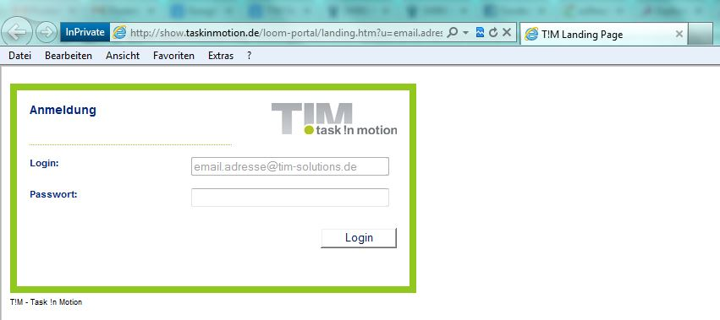
With this paramater you can preset the username in the login-interface. Here an E-Mail address or a username can be set.
landing.htm?u=email.adress@tim-solutions.de

The parameter (p)
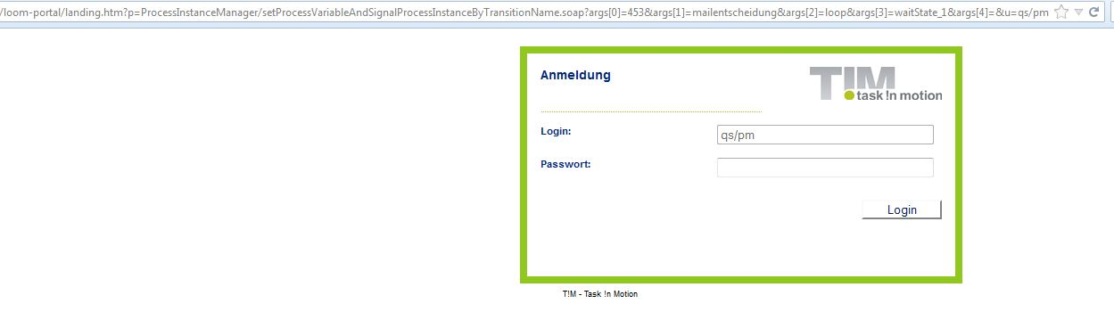
With this parameter you can set, where the user is forwarded to after authentication. Here only the address, that is after loom-portal, has to be put in.
landing.htm?p?=webservice.soap?arg1=entscheidung_freigabe&arg2=ablehnen&arg3=beispiel

Example process
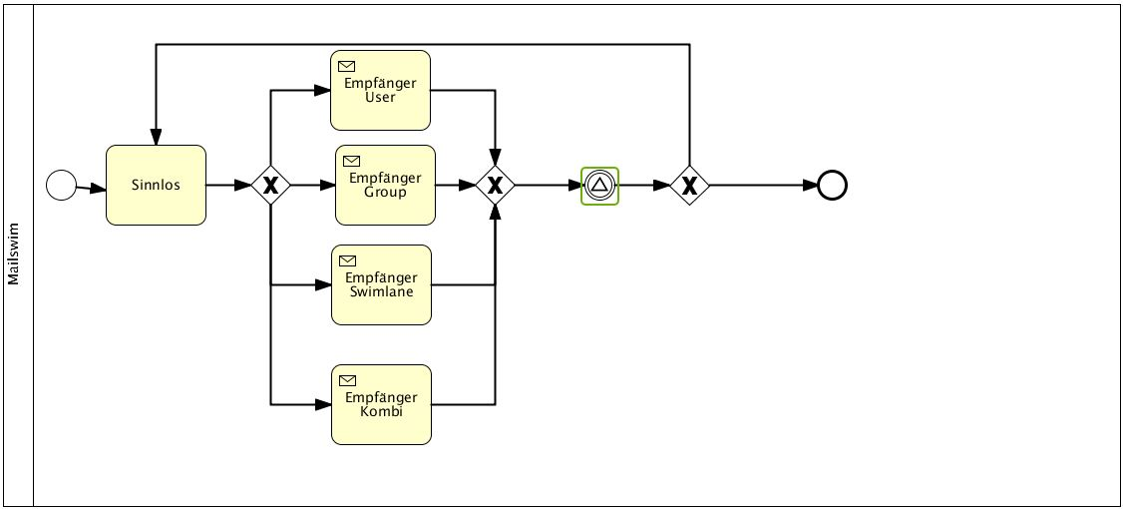
Dieser Prozess wartet am grün markieren Waitstate auf eine Entscheidung per Mail, ob der Prozess enden soll oder nochmals von vorne beginnt. Die Entscheidung wird wie folgt in Prozess eingebau
${BASELINK}landing.htm?u=qs/pm&p=ProcessInstanceManager/setProcessVariableAndSignalProcessInstanceByTransitionName.soap?args[0]=${processInstanceId}&args[1]=mailentscheidung&args[2]=loop&args[3]=waitState_1&args[4]=
${BASELINK}landing.htm?u=qs/pm&p=ProcessInstanceManager/setProcessVariableAndSignalProcessInstanceByTransitionName.soap?args[0]=${processInstanceId}&args[1]=mailentscheidung&args[2]=ende&args[3]=waitState_1&args[4]=
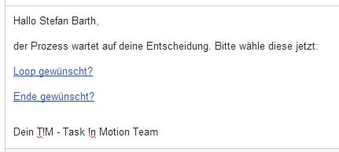
The result in the mail can look like this

