The mails aren't being sent -- what can I do?
The sending of e-mails automatically is dependent on various factors. Please check the following points. If the problem persists, please contact our support department.

Is the mail server set up correctly?
First, check if the mail server is set up correctly. You may find the guidelines for configuring the mail server from the Wiki pages for testing the e-mail configuration and client profile characteristics. Send a test message after the mail server settings have been adjusted (see Screenshot).
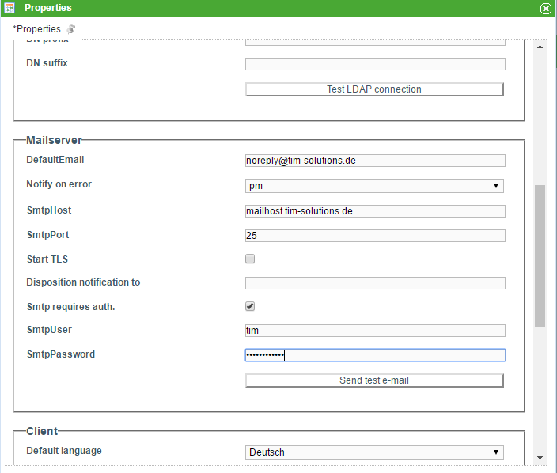
Should the problem persist, follow the following steps:

Is there an entry in your mail queue?
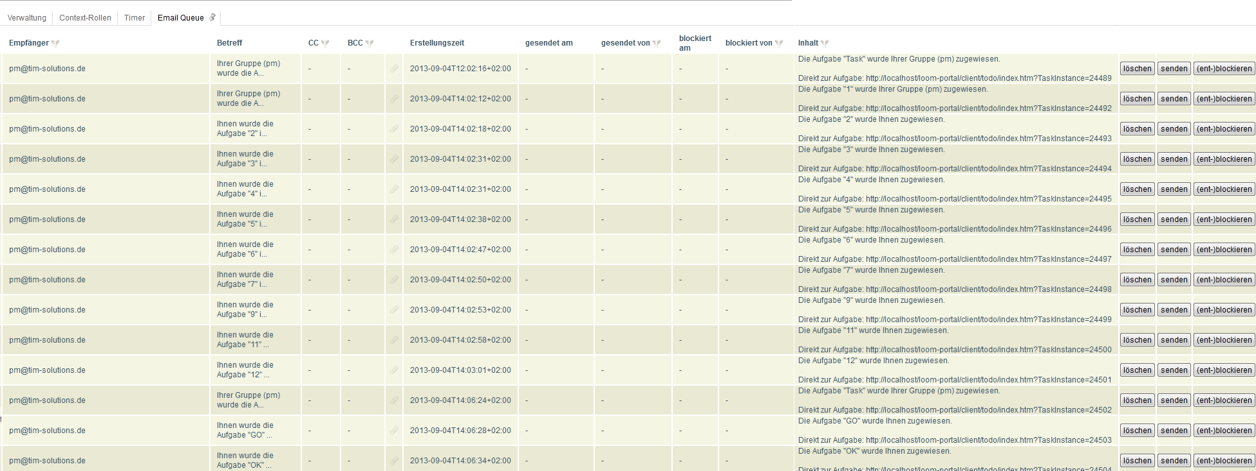
Please check if there is an entry for the intended e-mail in the mail queue. The mail queues can be viewed in the admin-client under the tab labeled e-mail queue (see Screenshot). If the mail queue contains an entry for the mail that was to be sent, continue adn check the next step. If there is no entry in the mail queue, please contact our support team.
 | Allow the column Error Report in the tabe to be viewable. If an error occurs while sending a message, this will be shown in the Error Report column. Instructions on how to make the column visible can be found in the table column configurations.

The mail queue shows an entry but the mail isn't sent.
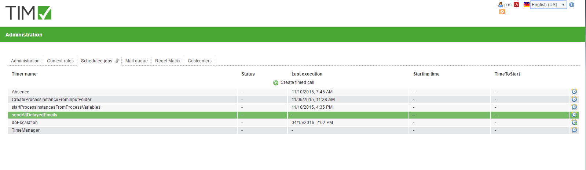
Check if the sendAllDelayedEmails timer was set and started. The list of created timers can be found in the admin-client under the Timer tab (see Screenshot).
 | If the sendAllDelayedEmails timer is started, the entire mail queue will be sent.
Should the problem still persist, continue and check the next step.

The timer is created and started but the mail isn't sent.
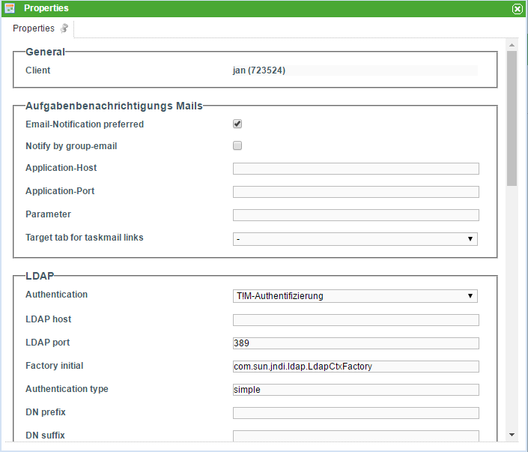
Check if the option Message per E-mail Preferred under Task Message Mails in the client profile is activated (if there is a check-mark) (s. Screenshot).
The client profile is reached by clicking on the client-icon in the admin-client.
Should the problem still persist, check if the mail server is configured correctly.

