This page is not fully translated, yet. Please help completing the translation.
(remove this paragraph once the translation is finished)

Adapt context roles
Via the administration client, context roles can be added and adapted. Context roles fulfill the task of alloting a separate role to a certain user within a process.
If a context role is adapted, the following window opens:
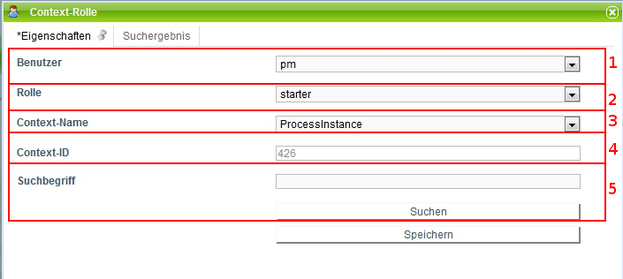
Element | Description
1 | Here, the user for which the role is created, is picked. A click on the dropdown will open it and all users arranged will be displayed. The one required can now be chosen.
2 | This dropdown serves for the selection of which of the above mentioned roles the user should play.
3 | Here, the context name is chosen, that is in which frame the context role is located.
4 | Here, the context-ID, which specifically indicates which definition/instance is designated for this role, is displayed. This field can not be adapted directly but is filled via the search (Element 5). See Suche

Search
In order to allot a precise merit to a context role, the search has to be used. For this, something has to be entered into the search field.
If process definition is chosen in the context name, then the name of the wanted process definition has to be entered in the search field.
If process instance is chosen, the name of the process instance for which the role is to be valid has to be entered in the search field.
The same counts for process-definition templates.
It is also possible to start the search without making an entry. A list of all possible results will then be released.
After a successful search the tab “Search result” will open.
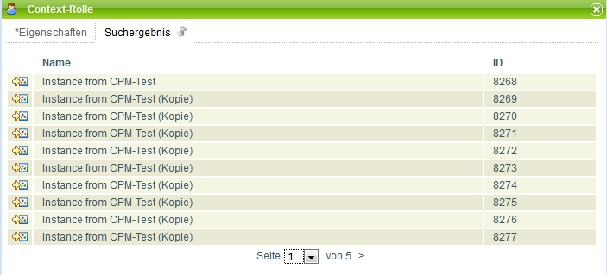
In this list the different instances which correspont with the search will appear. A click on an element of the list will get you to the tab “Properties” and the ID of the corresponding selection is noted in the context-ID field (Element 4).

Follow context roles
Please register in Admin Client with your admin user.
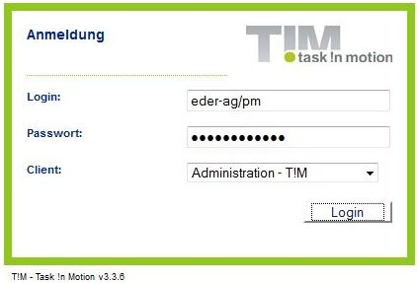
Choose the point User in the tab Administration and to a right click on the regarding user. Choose the point Ad context roles.
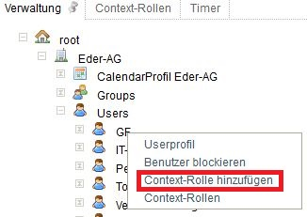
In the popup Context role you choose a role (preferably starter).
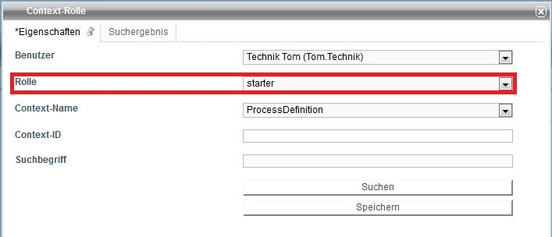
For the context name you choose process definition.
In the field search term you type the beginning of the corresponding process definition and click on the button search.
In the following popup the columns can be newly arranged via a click on ID. The top entry matches the latest process definition.
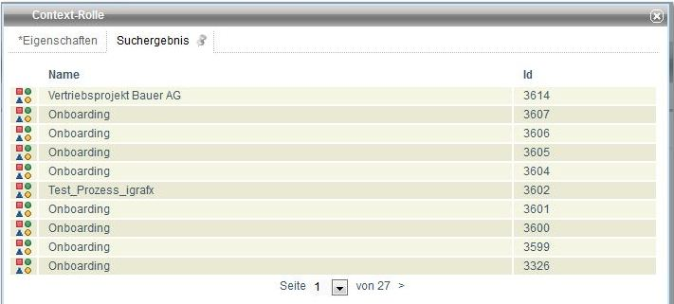
Choose the row with the highest ID of your definition via a click.
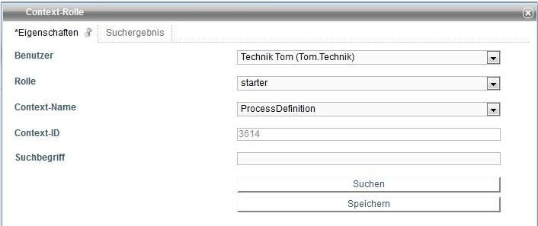
Via a final click on the button save you have updated the corresponding context role.

