This page is not fully translated, yet. Please help completing the translation.
(remove this paragraph once the translation is finished)

Properties
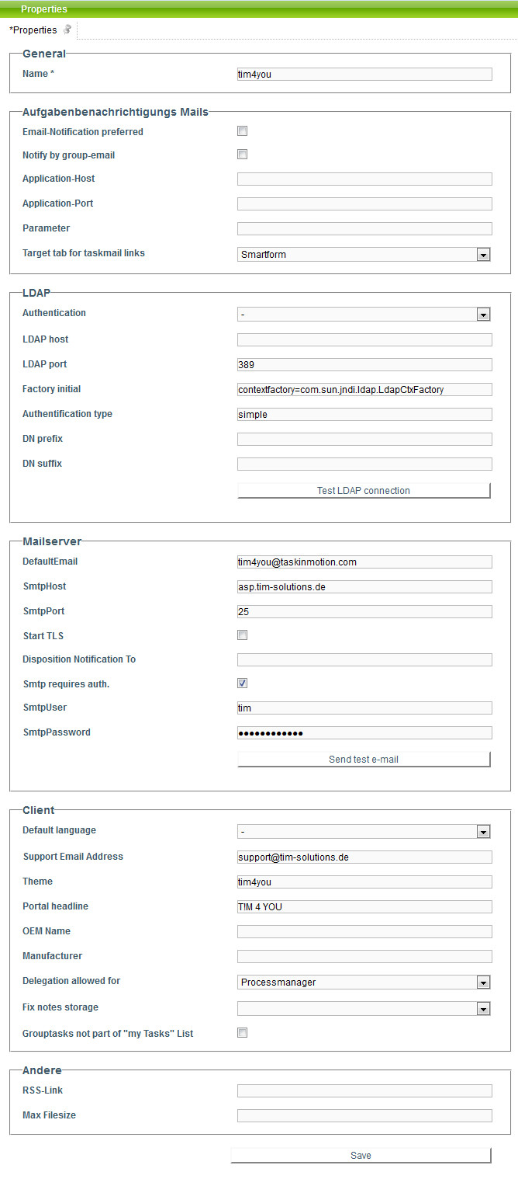

General
Field | Description
Name | The name of the client is entered in this field.

Licencing
Field | Description
Licence key | Here, a licence key, which sets the maximum number of users and processes, can be entered. However, as this is normally done via licence data in the T!M Engine, it is often not needed and empty.
Max. Users | In this field, you can determine the maximum number of users to be compiled in the corresponding client.
Max. Processes | Here, the maximum number of processes to be deployed can be entered.

Task notification e-mails
T!M - Task !n Motion composes the Taskmails, which are sent to the employees, from these parameters. Also, the ${baseLink} is composed from these parameters.
Field | Description
E-mail notification preference | In order to activate the T!M e-mail notification, the Checkbox must be activated.
Application-Host | Here, the host name of the server on which T!M was installed is displayed.
Application-Port | Here, the port of the server on which T!M was installed is entered.
Parameter | This field should only be adapted, if necessary, by a T!M employee.
Target tab of task mail links | Here, you can state which tab should be opened when a user has clicked on the link in a task mail. This setting applies to all users who were newly compiled.

LDAP
In this area the LDAP interface to T!M -Task !n Motion can be set up. You can get further information from dieser Seite.
Field | Description
Authentication | Here, you can specify an authentication interface. If this field is empty, the T!M- databank is used automatically. In order to establish a LDAP-Authentication, the parameter „ldap“ has to be entered.
LDAP-Host | If an LDAP-interface is used, the host name (the IP-address) of the LDAP-server has to be entered here.
LDAP-Port | If you want to use an LDAP-interface, the port of the LDAP-server has to be entered here (Standard is :389).
Factory Initial | The parameter which has to be entered here is needed for the initialization of the LDAP-interface and must have the parameter (com.sun.jndi.ldap.LdapCtxFactory).
Kind of Authentication | The kind of encryption of data during the transmission of the LDAP-interface has to be entered. The field can contain the parameters “simple” or “digest-md5”.
DNS Prefix | Here, a DNS Prefix for the network can be specified, if it is used in the network. In most cases this parameter can stay empty.
DNS Suffix | If a DNS-server exists in the network, the DNS Suffix has to be entered here. The parameter, which has to be entered here, has to be inquired of the network's IT.
Test the LDAP connection (Button) | Via a click on this button the accuracy of the LDAP-connectivity can be checked. You can get further information from dieser Seite.

Mailserver
Field | Description
Smtp Return address | The e-mail address, which is displayed as sender on the T!M- notification mails, is entered in this input field.
SmtpHost | Here, the IP or host name of the mailserver used has to be entered.
SmtpPort | Here, the port which the mailserver follows is entered (standard port :25).
Start TLS | Activates the TLS encryption to the mailserver if desired or necessary.
Absence message to | Returned absence messages can be forwarded to a certain mail box (which was entered here).
Smtp erfordert Auth. | Activates the authentication to the mailserver if necessary.
SmtpUser | Here, the user who has the right to send e-mails via the mailserver, is entered.
SmtpPassword | Specifies the password of the according Smtp user.
Test e-mail configuration (button) | Via a click on this button the dispatch of T!M- notification e-mails can be simulated in order to test their functionality. You can get further information from email_testing

Client
Field | Description
Support Emailaddress | Changes the display of the support e-mail-address in the information area of all Clients.
Theme | In this field, the Theme to be used is displayed. This is the name of the custom file.
Portal-Header | The text entered here becomes visible in every T!M-Client of the corresponding client. See

Producer | not required
Delegation allowed for
If “Case handler” is deposited, users with the right “member” can delegate tasks to co-workers of their group. |
Fix notes depot | If here, for example, process instance is chosen, all notes are attached to the process instance and not to tasks anymore. If “task” is chosen as parameter, but a note is attached to the process instance, the note will be attached to the instance anyway, as T!M - Task !n Motion does not know to which task of the instance the note should be attached to.
Group tasks not in “My tasks” list | Tasks tab either displays my tasks and tasks of my group or my tasks only.

Others
Field | Description
RSS-Link
Max. Data size | Here, the maximum size of data to be uploaded to the T!M-cliet can be determined.

