This page is not fully translated, yet. Please help completing the translation.
(remove this paragraph once the translation is finished)

Calendar profile
Via the calendar profile the administrator can enter the working hours which are specific for the business and therefore define a work day. This plays a role if a schedule for a process has to be defined. Its calculation is based on the work week defined here.
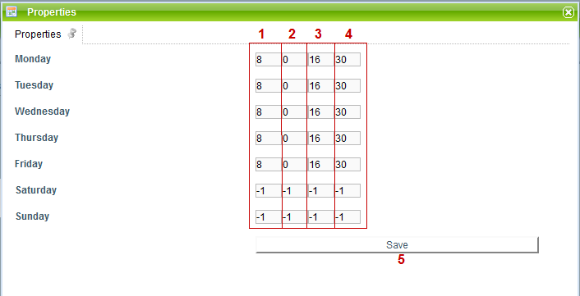
Element Description
1 | Here, the hourly part of the work start in the format of h or hh is entered for a particular day.
2 | Here, the every minute part of the work start in the format of m or mm is entered for a particular day.
3 | Here, the hourly part of the work end in the format of h or hh is entered for a particular day.
4 | Here, the every minute part of the work end in the format of m or mm is entered for a particular day.
5 | Via this button applied changes can be saved.
 | work-free days are marked through a “-1” entered in every column.

Add feast days
In T!M you can also add feast days which concern all T!M employees. The registered feast days are then substracted from the handling time of tasks. For this, you can add a new feast day via a right click on the context menu of the calendar profile and adapt it, accordingly.


