Emptying the cache in Internet Explorer 7
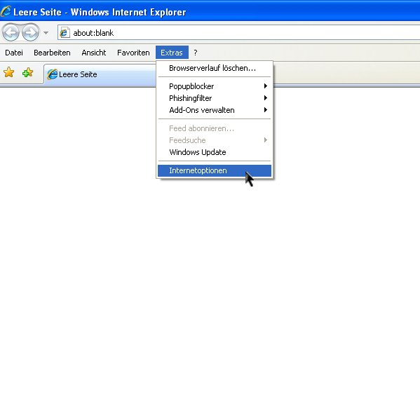
1. Within the Extras menu, click on Delete Browser History.

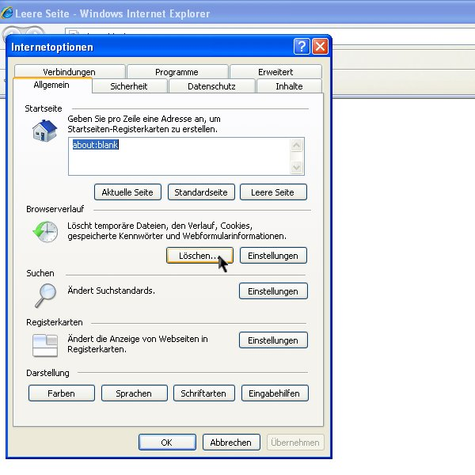
2. Within the General tab, go to the Browser History section and select Delete.

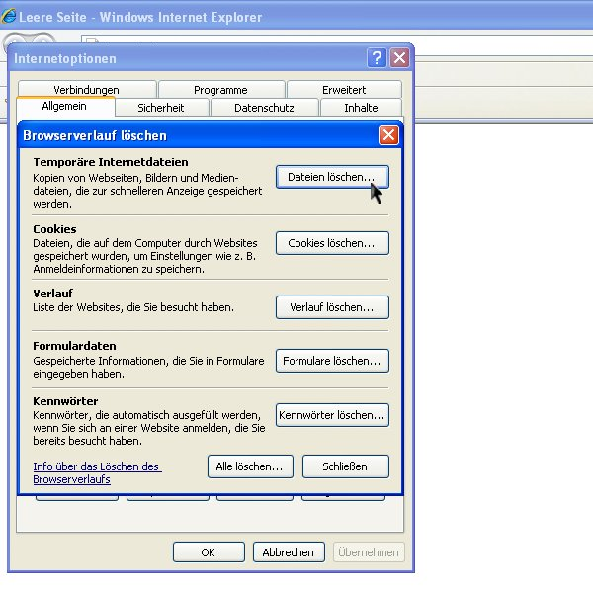
3. In the Temporary Internet Files click on Delete Files.

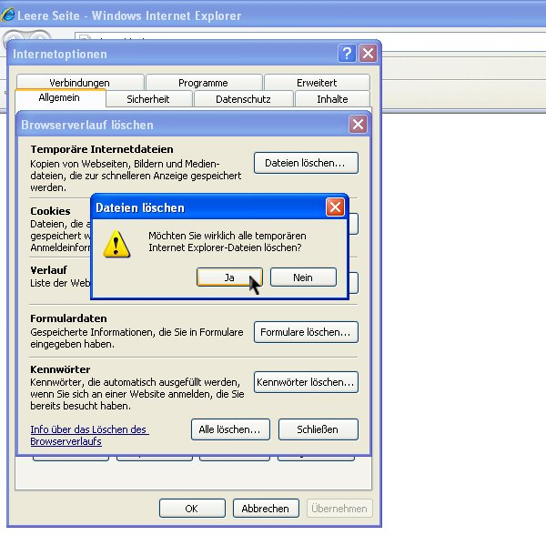
4. Confirm by clicking Yes.

