Purpose of the Module
The main process should be able to be terminated from the subprocess. Therefor in the subprocess it is decided (via XOR Gateway), whether the main process should be terminated or continued (again XOR) after the subprocess is finished.

Which actionhandler do I need?
In the subprocess Two handlers are needed at the decision point:
1. On Node Enter a processvariable is set with the ProcessVariableSetter. This is necessary for both decisions.
Handlerclass:
com.dooris.bpm.actionhandler.ProcessVariableSetter
Parameter for continuing the process:
name=endProcess;value=Yes;
Parameter for terminating the process:
name=endProcess;value=No;
2. On Node Leave the set variable is passed to the main process via the WriteBackProcessVariableHandler. On the directly following XOR decision in the main process the sent variable is checked and and decides whether the process hould be terminated or continued.
Handlerklasse:
com.dooris.bpm.actionhandler.WriteBackProcessVariableHandler
Parameter:
includedVariables=prozessBeenden;
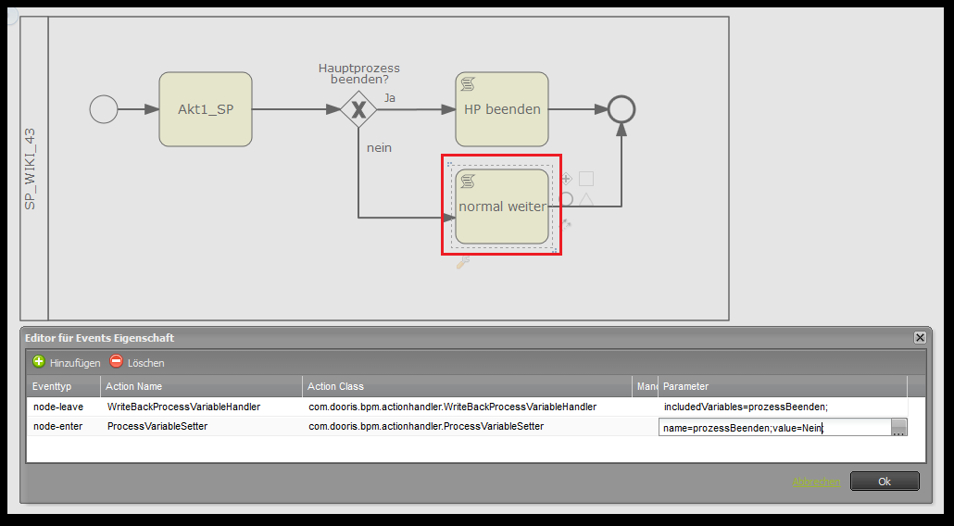
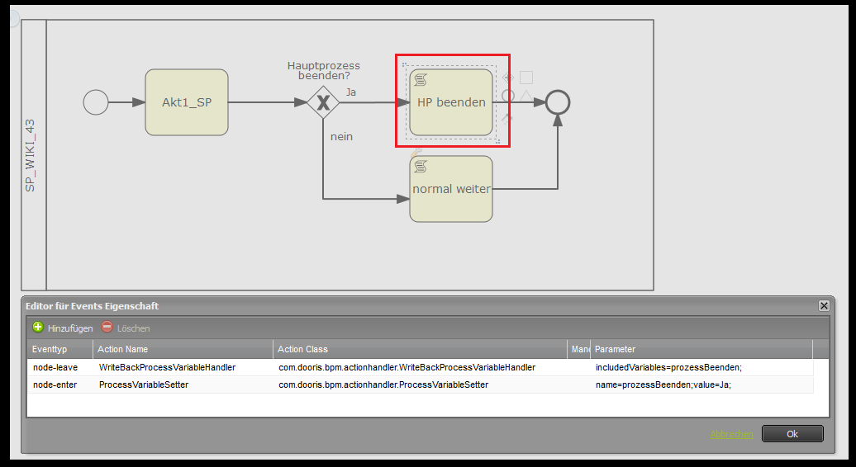

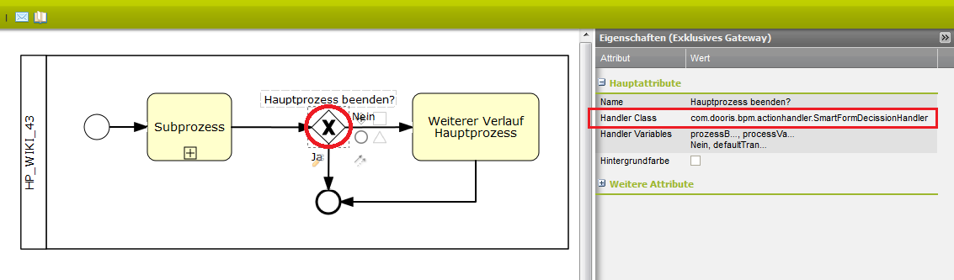
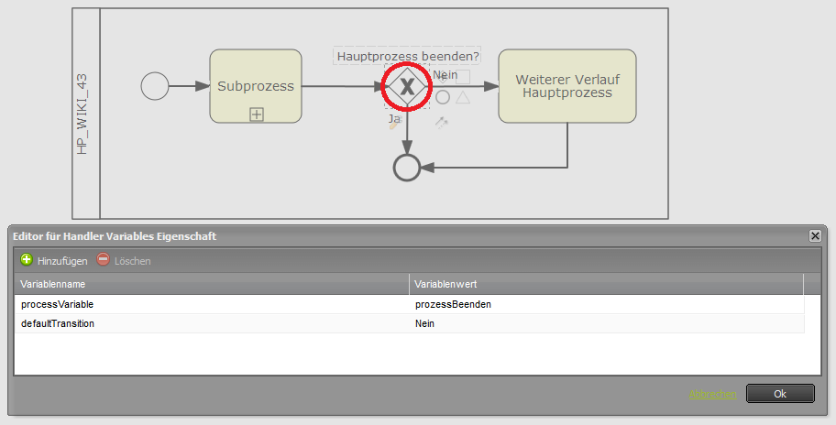
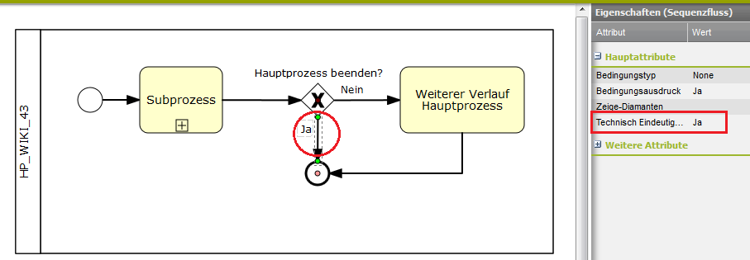
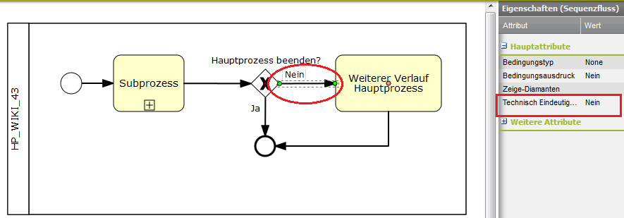
Im Hauptprozess wird, unmittelbar auf den Subprozess folgend, eine XOR-Entscheidung benötigt, um die vom Subprozess übergebene Variable zu übernehmen. Abhängig vom Wert der Variable wird hier nun entschieden ob der Prozess beendet oder weitergeführt wird. In the main process* following directly after the subprocess a XOR decision is needed to acquire the from the subprocess sent variable. Depending on the value of the variable it is here decided whether the porocess is terminate dor continued. 3. To check the in the subprocess set varible, the VariableDecisionHandler is used with the foloowing attributes: Handlerclass: <code> com.dooris.bpm.actionhandler.VariableDecisionHandler </code> ^Variablename^Variablevalue^ |processVariable|endProcess| |defaultTransition|No| The function “defaulTransition” is optional. It is used to determine a path of the following process sequence, in case no manual decision was made.
4. The tecfhnical unique name of the transition has to be assigned the value, which was assigned to the variable “endProcess” in the subprocess on the corresponding node via ProcessVariableSetter. On the transition that terminates the main process the technical unique name is set to “Yes”.
On the transition that continues the process, the technical unique name is set to “No”.
Processdownload Signavio:
main process: hp_wiki_43_sig.zip
subprocess:** sp_wiki_43_sig.zip

