Purpose of the component
Often a decision in TIM is made by many different departments or users. If one of them declines, it does not matter how the others decide and it is declined.

Which actitvities and gateways do I need in a process?
Activities and gateways that ar needed for implementation:
- XOR (amount depending on different users)

Which actionhandlers do I need?
Actionhandler that are needed for implementation:
- VariableDecisionHandler

Smartform
We need the option to release or decline for all 3 reviewer in the smartform.
<form>
Reviewer 1 <input type="radio" name="reviewer_one" id="reviewer_one_yes" value="yes"/> Yes <input type="radio" name="reviewer_one" id="reviewer_one_no" value="no"/> No
Reviewer 2 <input type="radio" name="reviewer_two" id="reviewer_two_yes" value="yes"/> Yes <input type="radio" name="reviewer_two" id="reviewer_two_no" value="no"/> No
Reviewer 3 <input type="radio" name="reviewer_three" id="reviewer_three_yes" value="yes"/> Ja <input type="radio" name="reviewer_three" id="reviewer_three_no" value="no"/> No
</form>

Integration
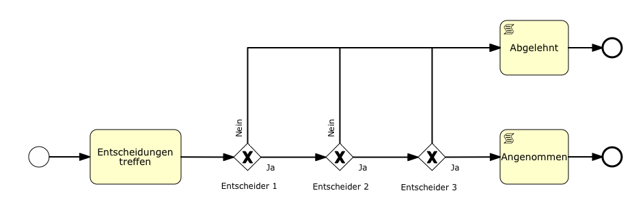

XOR´s
On the XOR gateway a VariableDecisionHandler is to be set, which accesses the releasevarible in the smartform.

