This page is not fully translated, yet. Please help completing the translation.
(remove this paragraph once the translation is finished)

YearIDGenerator

Description
The Handler creates an number, which can be used as a unique classification. Typically, the generated ID is connected by the RenameInstanceHandler. The generated ID is set-up as such: YYYYxxxx; in which YYYY is the current year und xxxx represents a sequential counter number (Example: 20110001).

Action Class
com.dooris.bpm.actionhandler.YearIDGenerator

Event Type
any type

Action Name
any text

Mandatory Fields
Here, the user can set a variable to which the created value is written. See Example
 | Caution: The variable name “id” may not be used!

Parameter
The generated ID can be called on using the variable #{key}, and can then be processed in the handler. If the variable is required as a process variable in the process development, the mandatory field must be set!

pattern
This parameter is optional and can be used to build Process variable(s) into Process instance names. Here, the variable #{key} can be called upon. See Example

length
The “length” parameter increases the ID length by a specified number of consecutive numbers.
“length” can be set manually. For instance, if “length=5” is entered, the ID will be composed of the current year + 5 consecutive numbers.
If nothing is set manually, the ID is composed of the current year + 4 consecutive numbers by default.

prefix
This adds a specified prefix to the generated ID, with a blank space between the prefix and the ID
This parameter is only chosen when the pattern parameter is not being used!

Example
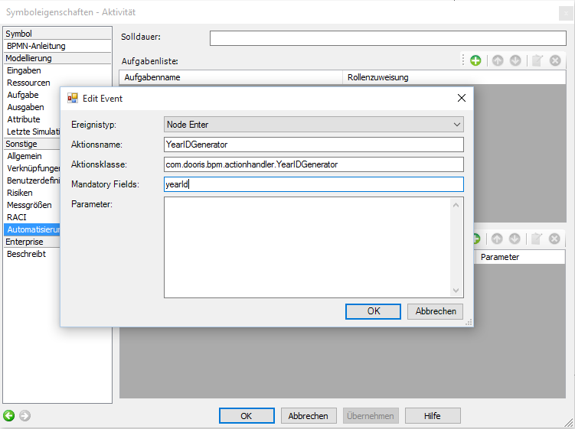
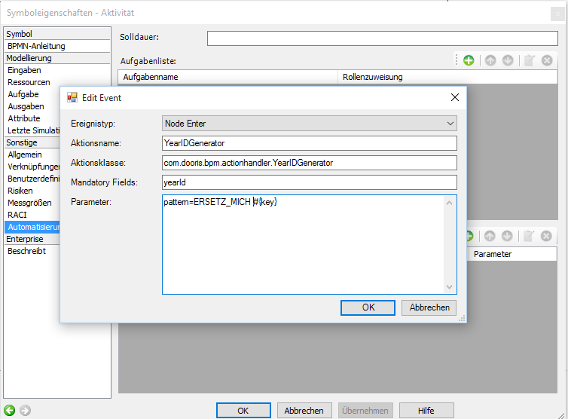
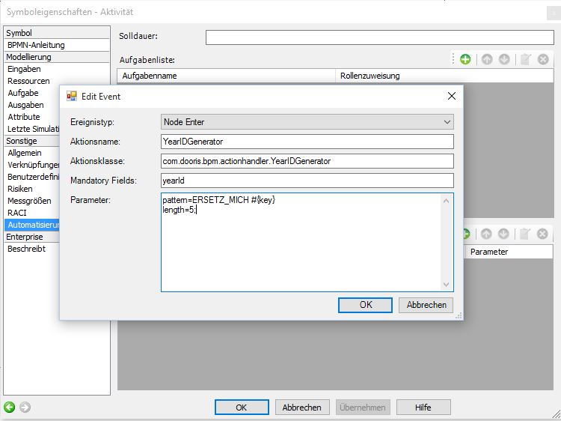
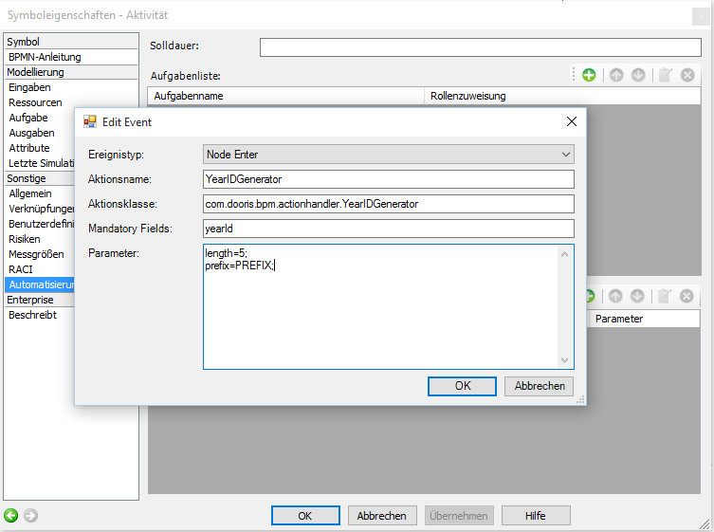
Example 1
Four-digit ID is generated and given an instance name. The ID is saved in the yearID process variable.
Example 2
Four-digit ID is generated and the pattern is set as the instance name. The ID is saved in the yearID process variable. In this example, the process instance is now named “ERSETZ MICH 20140003”.
Example 3
Five-digit ID is created and the pattern is set as the instance name. The ID is saved in the yearID process variable. In this example, the process instance is now named “ERSETZ MICH 201400004”.
Example 4
Five-digit ID is created. The instance name is now composed of the given instance name, the prefix, and the ID together. The ID is saved in the yearID process variable. In this example, the process instance is now called “Instanzname PREFIX 201400005”.

