This page is not fully translated, yet. Please help completing the translation.
(remove this paragraph once the translation is finished)

ICalHandler
This handler allows an appointment, which has been created in a smart form, to be sent to all participants.

Action Class
com.dooris.bpm.actionhandler.ICalHandler

Event Type
any

Action Name
any

Mandatory Fields
none

Parameter

eventName
Name of the meeting. May be derived from process variables --> $(processvariable)
(see example).

description
Description of the meeting. May be derived from process variables --> $(processvariable)
(see example).

location
Location of the meeting. May be derived from process variables --> $(processvariable)
(see example).

start
Start of the meeting.
i.e. in the format: dd.MM.yyyy HH:mm:ss => 13.02.2013 17:00:00 (see Pattern)
May be derived from process variables --> $(processvariable)
(see example).

end
End of the meeting.
i.e. in the format: dd.MM.yyyy HH:mm:ss => 13.02.2013 19:00:00 (see Pattern)
May be derived from process variables --> $(processvariable)
(see example).

organizer
Organizer of the meeting.
May be derived from process variables --> $(processvariable)
If the organizer is derived from a process variable:
${organizer}
Process variable: organizerEmail --> Email Address
Process variable: organizerRealName --> Name displayed in the meeting request.
If the organizer is given directly to the handler:
Format: email?name
(Usage of “selectUsersByGroupByClass” is possible!).
(see example).

attendant
Participants of the meeting.
May be derived from a process variable --> $(processvariable)
If the participant is derived from a process variable:
${attendant}
attendant[0]Email
attendant[0]RealName
attendant[1]Email
attendant[1]RealName
Or: ${attendant} -> E-mail addresses are separated by commas!

If the participant is given directly to the handler:
Format: E-mail addresses are separated by commas!
(Usage of “selectUsersByGroupByClass” is possible!).
(see example).

datePattern
The pattern depicting how the date variables are formatted.
z.B.: dd.MM.yyyy

fullTime
Controls if the last day of the entry should be counted as an all-day event. This is set to false by default.
Example: fullTime = true;

Example
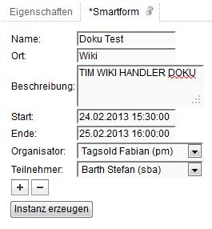
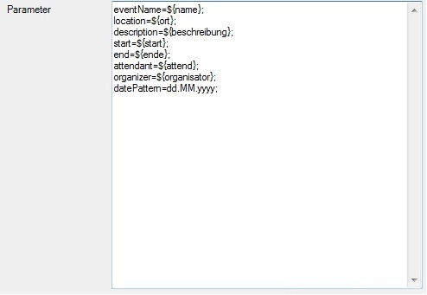
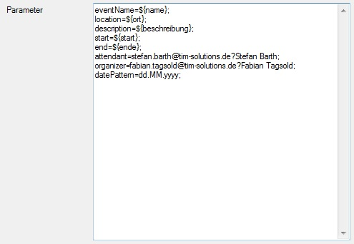
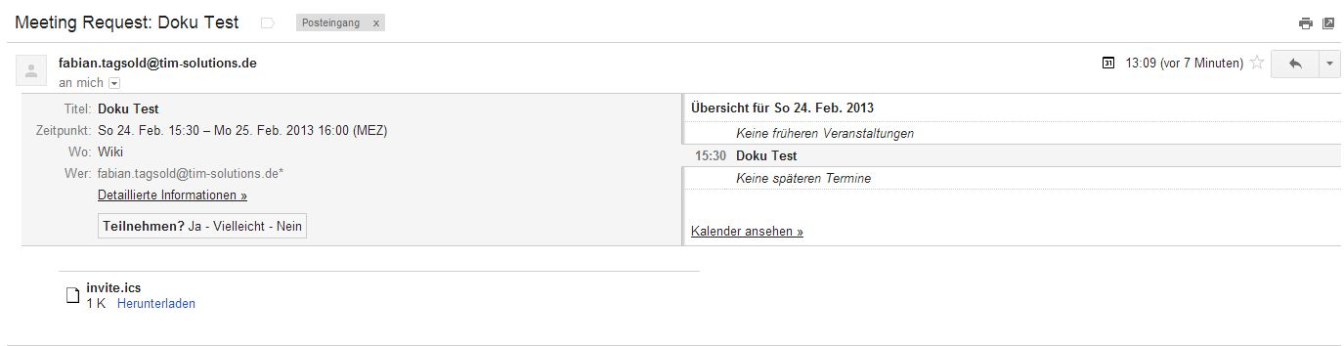
Possible smartform:
Parameter possibility 1:
Parameter possibility 2:
E-mail:

