This page is not fully translated, yet. Please help completing the translation.
(remove this paragraph once the translation is finished)

CheckMandatoryEfforts

Description
This action handler checks if an effort has been added. Because it only makes sense to use efforts for Tasks, this handler is only intended for use in combination with the addactionhandlertonodes handler.

Action Class
com.dooris.bpm.actionhandler.CheckMandatoryEfforts

Event Type
any

Action Name
any

Mandatory Fields
-

Parameter

type
This value should match the type of the task being proofed. These may be defined as FinanceEffort and TimeEffort. If both types are being proofed, both values should be entered and separated by a comma.

Example
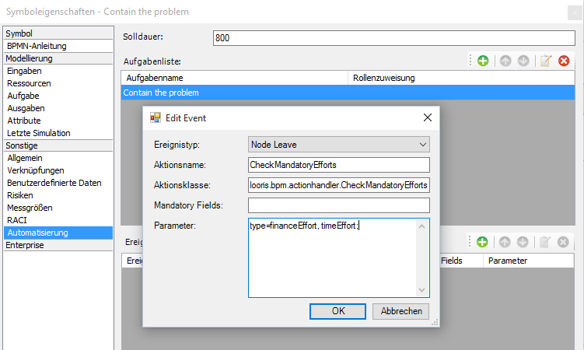

Dependencies
TIM Version : v3.5

