Requirements for an analysis
A standard SQL statement can be initiated in order to conduct an analysis. For this analysis to be successful the predefined database views have to be used. The new structure can be seen here .
 | ​Please note the comments further down on the page!

An Overview of the Tables
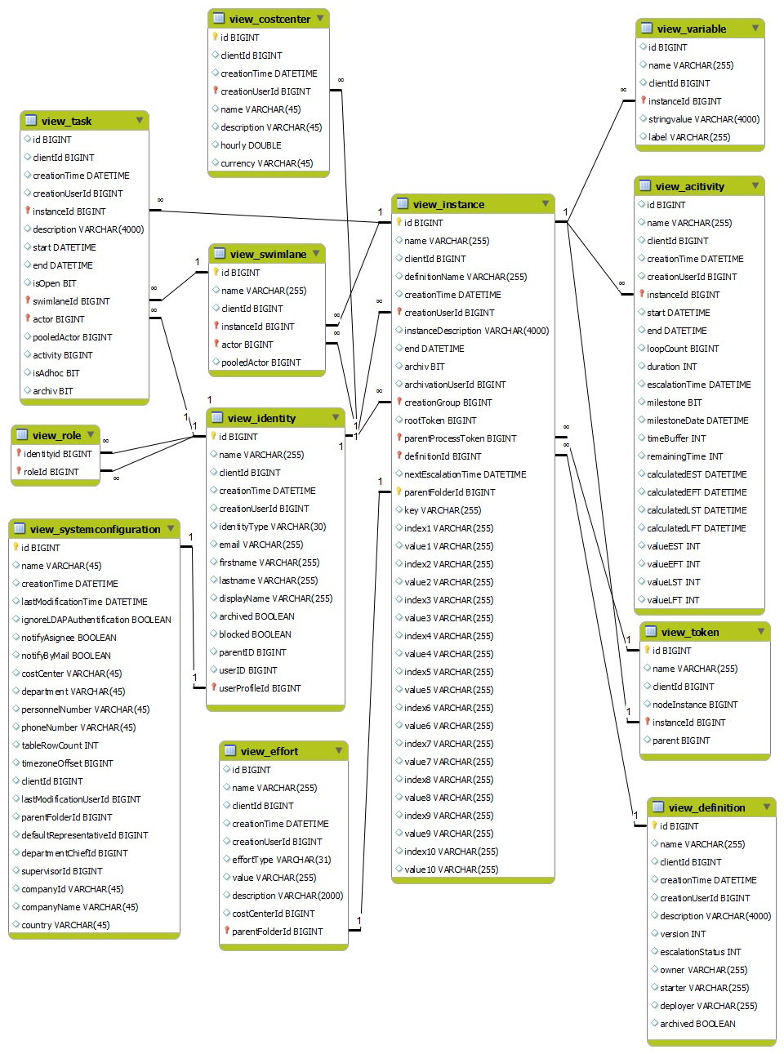

Explanation of the Table Contents
the clientID field always references the id of the view_identity

view_activity
- id: The unique identification number used throughout the entire database
- name: Name of the activity
- clientId: A number referencing a specific client
- creationTime: The exact point in time when the activity was initiated
- creationUserId: A number referencing the impacted user
- instanceId: A number which references an impacted instance in which the activity is active
- start: The exact point in time when this activity was started
- end: The exact point in time when the activity was finally terminated
- loopCount: The number of runs of an activity
- duration: The maximum duration of processing time assigned to this activity
- escalationTime: The calculated point in time for the next escalation within the activity
- estimatedEnd:​ Shows the estimated end-date of the acticity
- milestone: This entry displays if this activity is considered to be a milestone indicating the achievement of a certain benchmark
- mileStoneDate: The point in time when this milestone has to be accomplished
- elapsedTime: Shows the time which has already been taken for task completion
- inTime: Shows if the activity is still running in accordance with the time-plan
- timeBuffer: Calculated “buffer” time for the activity
- calculatedEST: The calculated earliest starting time
- calculatedEFT: The calculated earliest ending time
- calculatedLST: The calculated latest point in time for starting
- calculatedLFT: The calculated latest point in time for ending
- valueEST: The net time specification for the earliest starting point (contains the Business Calender)
- valueEFT: The net time specification for the earliest ending point(contains the Business Calender)
- valueLST: The net time specification for the latest starting point(contains the Business Calender)
- valueLFT: The net time specification for the latest ending point(contains the Business Calender)
- type: Returns the type of the activity (scriptnode, tasknode, mailnode, etc.)

view_definition
- id: The unique identification number used throughout the entire database
- name: The name of the process definition
- clientId: A number referencing a specific client
- creationTime: Point in time at which the process definition was deployed
- creationUserId: The unique ID of the user who deployed the task instance
- description: A description of the process definition
- version: Version in which the process definition is found
- escalationStatus: Information pertaining to the escalation status o the process
- owner: The user or group responsible for the process
- starter: User or group who has the right to start the definition
- deployer: User or group who has the right to deploy the definition
- archived: Tells whether or not the instance has already been archived

view_effort
- id: The unique identification number used throughout the entire database
- name: The name assigned to the effort
- clientId: The number corresponding to the impacted client
- creationTime: The point in time at which this effort was made
- creationUserId: The unique ID of the user who is responsible for causing the effort
- effortType: The type of effort (“time invested” or “money spent”)
- value: Information on the value of the effort without using an unit
- description: Description of the effort
- costCenterName: The name of the cost center responsible for the effort
- instanceId: The number corresponding to the impacted instance
- parentFolderId: The number corresponding to the impacted virtual index

view_identity
- id: The unique identification number used throughout the entire database
- name: Name of the user
- displayName: Contains the complete name and user name (i.e. John Doe (J. Doe))
- clientId: A number corresponding to the client at hand
- creationTime: The point in time when this identity/user was created
- lastLogin: Contains the time at which the user last logged in
- creationUserId: The number corresponding to of the user who created this user/group/client
- identityType: The type of identity/user (e.g., user, group, client)
- email: The e-mail address of the user or group
- firstname: The first name of the user
- lastname: The surname of the user
- archived : Indicates if this iuser/group/client has already been archived
- blocked: Indicates if this iuser/group/client is blocked
- userID: Contains a number pointing to a user who belongs to this community
- parentID: Contains the number, which points to the group who belongs to this community

view_instance
- id: The unique identification number used throughout the entire database
- name: The name of the process instance
- definitionName: The name of the superordinate process definition
- clientId: A number affiliated with client of the process instance
- creationTime: The point in time at which the process instance was started
- key: This displays the value generated by the YearIDGenerator, assuming that this functionality is enabled
- creationUserId: A number corresponding to the user who started this process instance
- definitionId: A number corresponding to the process definition that is at the base of this instance
- instanceDescription: An additional description of the process instance
- creationGroup: A number corresponsing to the group that initiated the process instance
- end: This is the exact point in time when the process instance was terminated
- archive: This reports if this process instance has already been archived
- archivationUserId : This provides information on the UserID of the user who archived this instance
- rootToken: This entry gives details about the progress of the process instance (the current node is marked by this token)
- parentProcessToken: If the current process instance is only a subordinate process, then this is the token attributed to the related main process
- nextEscalationTime: This entry shows the calculated point in time pertaining to the next escalation of the process
- processVariableIndex: —-
- index1-10 and value1-10: Important information of the process instance, the worth of which stands in value and the position is given over the index.

view_swimlane
- id: The unique identification number used throughout the entire database
- name: name of the swimlane
- clientID: A number corresponding to the client at hand
- instanceId: A number corresponding to the corresponding instance
- actor: A number corresponding to the associated user
- pooledActor: A number corresponding to the associated group

view_task
- id: The unique identification number used throughout the entire database
- name: Name of the task
- clientId: A number referencing a specific client
- creationTime: The exact point in time when the task was initiated
- creationUserId: A number referencing the impacted user
- instanceId: A number which references an impacted instance in which the task is active
- start: The exact point in time when this task was started
- end: The exact point in time when the task was finally terminated
- isOpen: Denotes if a task has already been completed (Caution! not all signal-methods complete tasks)
- swimlaneId: Contains a number referencing the swimlane in which the tasks is held
- actor: A number corresponding to the associated user
- pooledActor: Contains a number referencing the currently associated group
- activity: contains a number there corresponds to the superordinate activity
- isAdhoc: Shows whether this activity was ranked as an AdHoc-task or not
- parentFolderId: A number corresponding to the impacted virtual index
- archive: This reports if this task has already been archived
- remainingTime: Shows the time which remains for task completion
- elapsedTime: Shows the time which has already been taken for task completion

view_token
- id: The unique identification number used throughout the entire database
- name: The name of the token
- clientId: A number referencing a specific client
- nodeInstance: Contains the number of the activity corresponding ot this task
- instanceId: Contains the number corresponding to the associated instance
- parent: The number corresponding to the main process

view_variable
- id: The unique identification number used throughout the entire database
- name : Name of the instance variable
- clientId: A number referencing a specific client
- instanceId: A number referencing the corresponding instance
- stringValue: Contains the content of the process variable
- label: Contains the label associated with the process variable

view_role
- identityId: Contains the number corresponding to the currently-associated user
- roleId: Contains the number corresponding to the currently-associated role

view_costcenter
- id: The unique identification number used throughout the entire database
- clientId: A number referencing a specific client
- creationTime: The exact point in time when the cost center was initiated
- creationUserId: A number referencing the user who created the cost center
- name : Name of the cost center
- description: Description of the cost center
- hourly: Contains the hourly rate of the cost center
- currency: The currency in which the cost center is calculated

view_systemconfiguration
- id: The unique identification number used throughout the entire database
- name : The name of the configuration
- creationTime: Contains the creation time of the configuration
- lastModificationTime: Contains the time at which the profile was last modified
- ignoreLDAPAuthentification: Field “ignore LDAP Authenfication” in the userprofile
- notifyAsignee: Field “Notify asignee if his task is done by somebody else” in the userprofile
- notifyByMail : Field “Email-Notification preferred” in the userprofile or from the client profile
- costCenter : Cost center of the user in the userprofile
- department: Department of the user in the userprofile
- personnelNumber : Personnel number of the user in the userprofile
- phoneNumber : Phone number of the user in the userprofile
- tableRowCount : Field “Display table rows” in the userprofile
- timezoneOffset : Timezone of the user in the userprofile
- clientId : A number corresponding to the impacted client
- lastModificationUserId: User who did the last changes on this userprofile
- parentFolderId : A number corresponding to the virtual directory
- defaultRepresentativeId : Contains a number that corresponds to the user who is stored as the substitute in the Userprofile
- supervisorId :The unique ID of the supervisor assigned to the userUserprofile
- companyId : Field “Company ID” of the user from the Userprofile
- companyName: Field “Company Name” of the user from the Userprofile
- country: Field “country” of the user from the Userprofile

