1. Generating and editing process models
An installed version of the “iGrafx FlowCharter” or “iGrafx Process 2013” (this program includes the iGrafx FlowCharter) is necessary in order to model processes with iGrafx and to deploy (i.e. publish) them in TIM. In addition, to add TIM-specific attributes to the BPMN process model the iGrafx4TIM plugin has to be installed. If there are any questions pertaining to the topic of available licenses, please refer to the respective administrator.
This section explains the basic functions for working with process models:
- How to create a model
- How to edit process models
- On formatting links
- On opening and saving charts
- How to convert an existing process chart into BPMN-format

1.1 Starting iGrafx4TIM
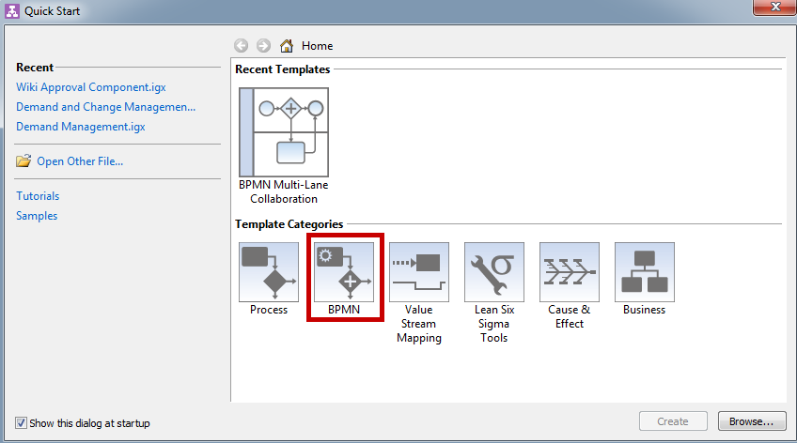
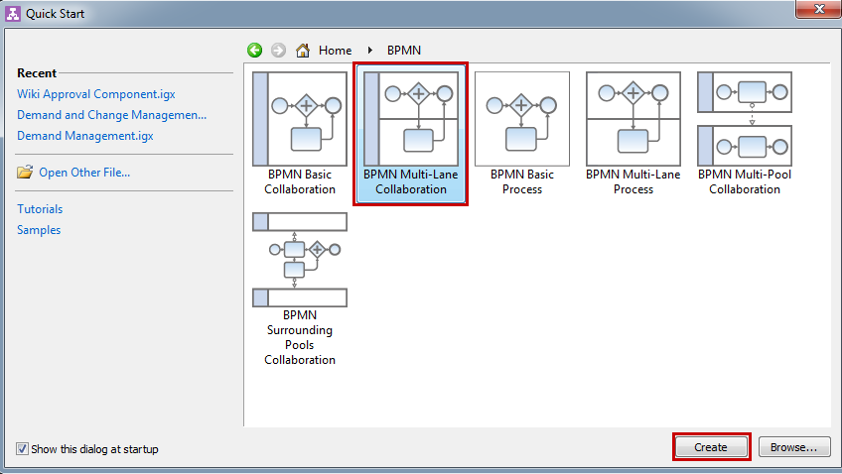
The quick-start pop-up will appear after starting the iGrafx FlowCharter or the iGrafx Process 2013 program. Now, the user must choose between six different template categories. To generate a TIM-compatible process model, the option “BPMN” is selected from the menu.
To select a TIM-exportable and -compatible chart with, for example, a “BPMN Multi-Lane Collaboration”, should be chosen. The selection is confirmed by clicking on the “Create” button.

1.2 Creating a new model
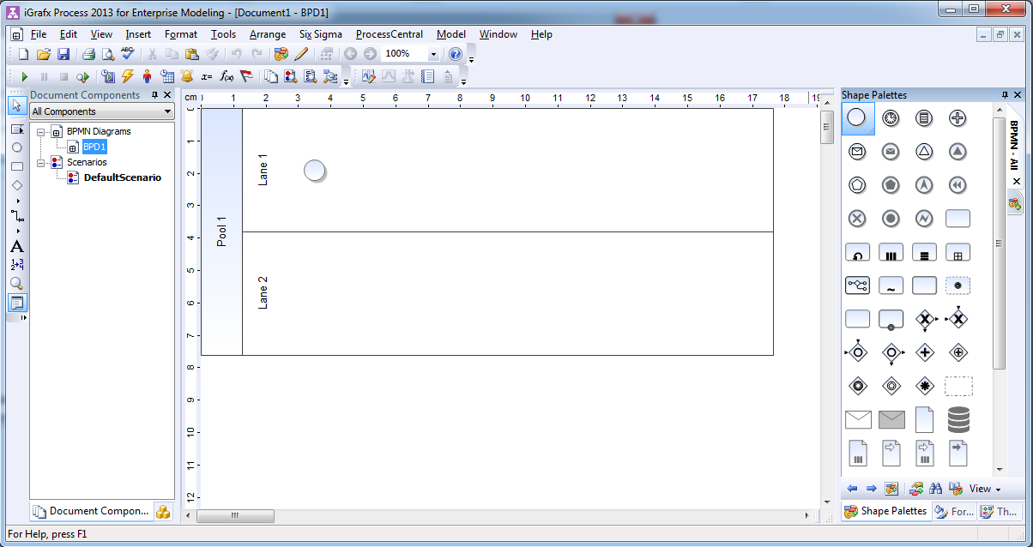
After selecting the desired BPMN process chart the iGrafx modelling interface appears.
By default, two separate Swimlanes and a starting event are integrated into the chart. Now, additional elements may be added to the model.
The name of the process can be changed by right-clicking on the editor on the left-hand side and then selecting the option “Rename”. The default name is always BPD1.
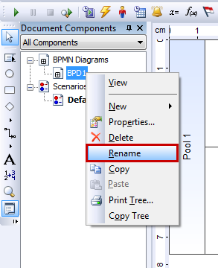

1.3 Editing process models
There are two alternative options available for editing elements to models:
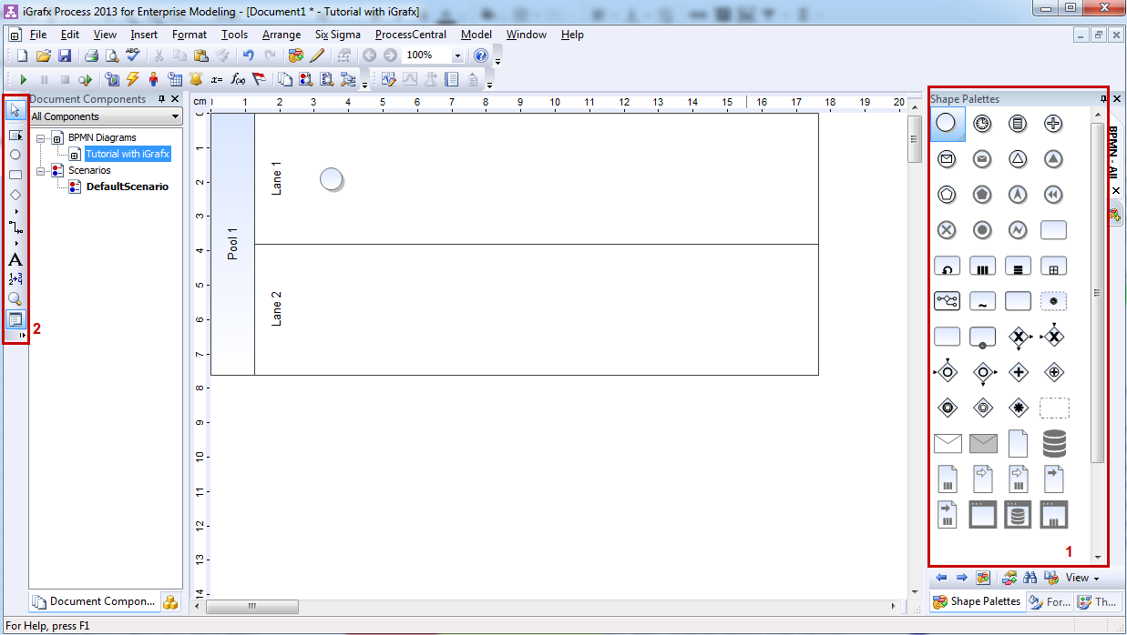
1. Either by dragging-and-dropping elements from the selection of symbols (1) on the right-hand side of the editor onto the drawing area in the center, or
2. by clicking on the tool menu (2) on the left-hand side and directly selecting the desired symbol.
The mouse cursor will change into a pencil-icon. This is then placed on the desired location within the chart. The selected symbol will be inserted by simply clicking again.
Both panels can be enabled and disabled via the context menu View.

Labeling elements
Elements can be positioned within the chart at free will. Horizontal and vertical lines are shown as aids to ensure the desired placement of elements.
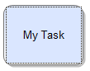
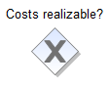
Elements can be given unambiguous labels. For example, if you click on the element “Activities” a text box will appear in which you can enter a specific name.
Not every symbol can be labeled by entering the name into the corresponding text field. If this is not possible, the cursor will indicate that the name can alternatively be added either above or below the symbol.

Positioning new elements
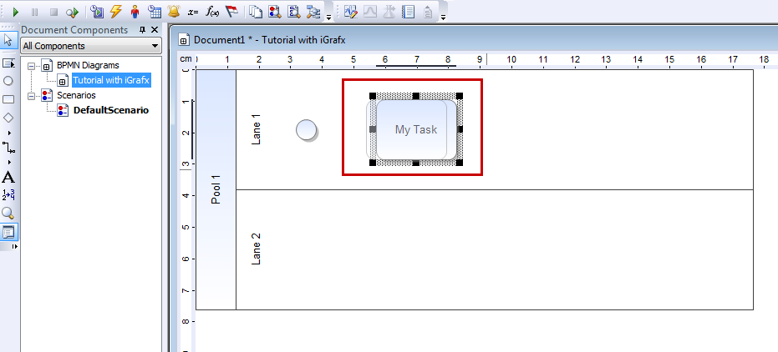
To set the position of a newly generated element, it can be manually placed by clicking on the symbol and positioning it at the desired location in the chart while holding the mouse-button. First, ensure that the mouse cursor is activated instead of the aforementioned pencil-icon (i.e. the first symbol depicted in the tool menu on the left-hand side of the editor!). Second, make sure that the cursor is placed on the highlighted boundary of the element until the symbol for moving objects is indicated.

Adding links between already existing elements
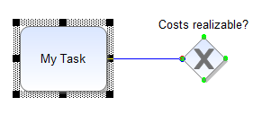
1. Select the element from which the link emanates.
2. Click on the starting element and move the pencil-icon for modeling to the targeted element while pressing the mouse the button. The green colored markings indicate which elements can be connected and at which point the connecting arrow of the link may be docked. For example, it is not possible to connect two starting events in BPMN-format.
3. As a result, a link will be generated. The exact type of the link will be determined by the type of elements it is connecting. For example, two BPMN tasks are connected by a link symbolizing a sequence flow, while two pools are connected by a link representing the flow of information.

Deleting elements
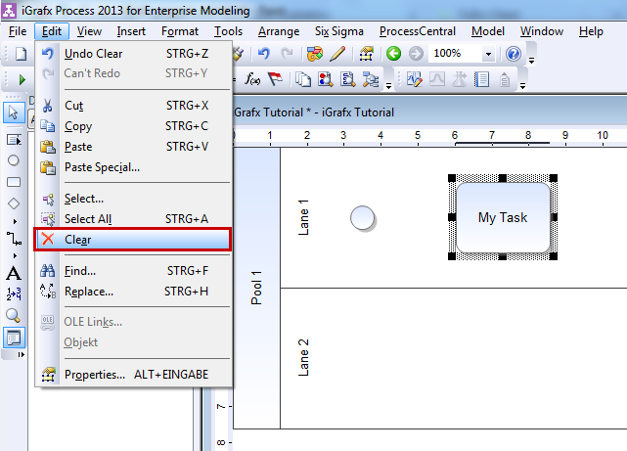
1. Select the elements for deletion.
2. Press either the Delete Key or the Return Key on the keyboard or click on the “Delete” button in the edit-section of the menu bar of the user interface.
Options for cutting, copying and pasting selected elements are available via the common key combinations Ctrl-X, Ctrl-C and Ctrl-V as well as the corresponding buttons in the edit-section of the menu bar.
 | Note: Several elements may be selected by either holding the Ctrl Key on the keyboard and clicking on them or by drawing a frame to select them in the drawing area.

Changing the size of elements
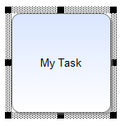
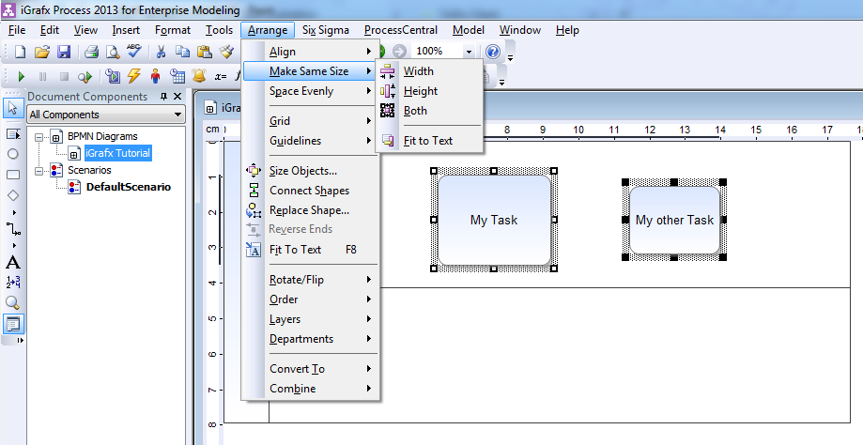
1. Select the element for which the size should be changed. A black frame with black squares in each corner and on the sidelines will appear around the margins of the selected element.
2. Click on any of the black squares and redraw the selected element to be the desired size by holding pressed the left mouse-button.
Note: If several elements are selected simultaneously and then the Ordering-section is opened in the menu bar, the option Same Sizenay be selected. This option will enable you to adapt the height and width of all selected elements one after the other or all at once.

Undo or restore actions
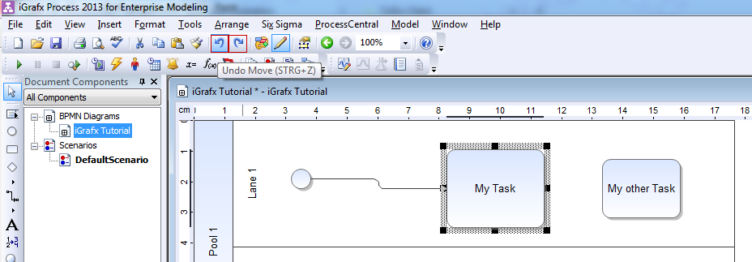
Actions and changes may be undone or restored by clicking on the “Undo”-button in the tool bar. The “Restore” button is located next to the “Undo” button, and the action being undone or restored is always indicated.

1.4 Formatting of transitions

Automatic formatting of transitions
Two actions will activate the automatic formatting function:
1. By generating a new transition
2. By moving or changing the size of an element

Manual layout of transitions
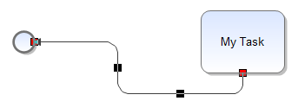
Moving the mouse cursor to a docking point of an element and connecting the ensuing transition to any other docking point highlighted in green results in a change of the shape and appearance of the transition. Also, black squares representing pivot points appear. These pivot points may be manipulated by clicking on the black squares and moving them.

Labeling transitions
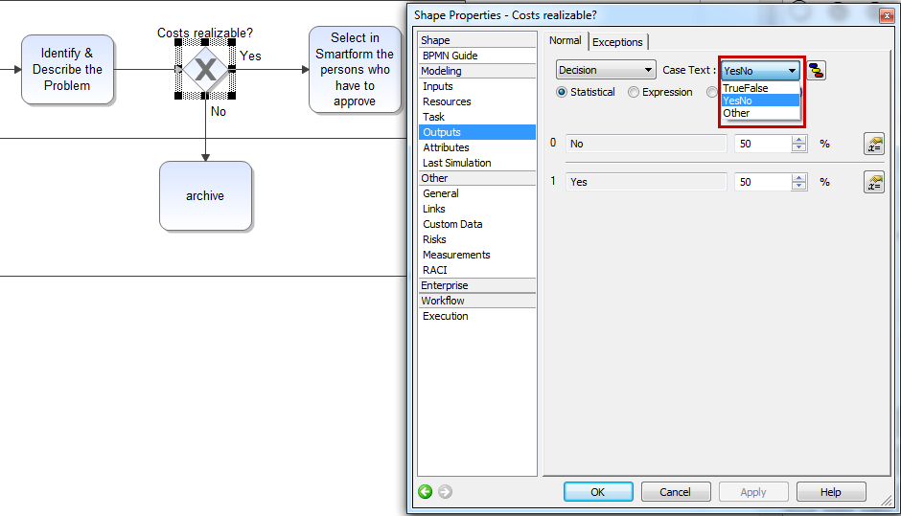
An automatic labeling of transitions (“yes/no”) occurs when generating XOR-Gateways. If this labeling is to be changed, the window to change the properties of symbols is opened by double-clicking on the selected element. There, the labeling of outputs may be changed via the “Outputs” section.
By selecting “Others” in the drop-down menu, the labeling may be changed as desired. To confirm any changes, simply click on “OK”.

1.5 Working with pools and lanes
Pools and Lanes are constructs for modeling within BPMN that enable organizational units, individuals and systems to be assigned to specific activities.

Adding pools and lanes to a chart
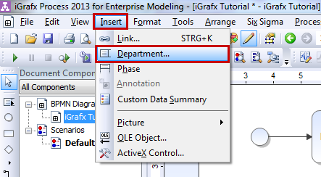
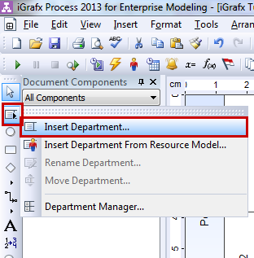
Pools and Lanes (Swimlanes) can be edited via the so-called Department Manager built into iGrafx.
The Department Manager may be found either in the menu “Add” in the Department-section or in the tool bar.
There are two different versions of pools: open and closed. Closed pools do not accept any further element for modeling and therefore represent abstract units of organization or systems. Open pools can be further subdivided by different Swimlanes. In turn, Swimlanes can be subdivided into so-called Sub-Lanes.

Creating a pool
The starting point is the graphic modeling interface with the standard settings including lane 1 and lane 2 as well as the starting event.
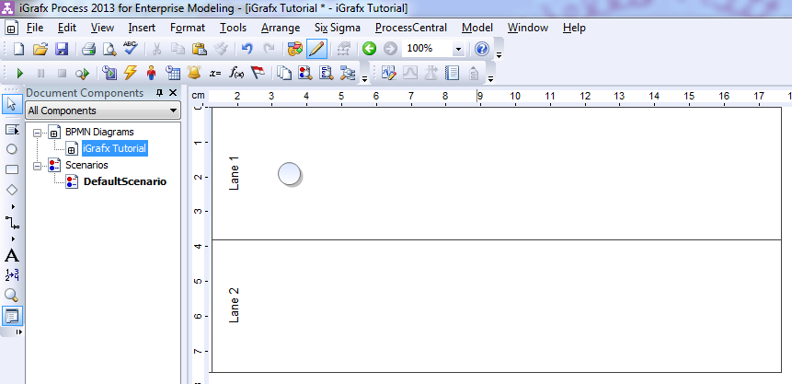
1. Open the Department Manager by clicking on the corresponding symbol in the tool bar. Both lanes will be shown and the chart is now ready for editing by clicking on the option “Add”.
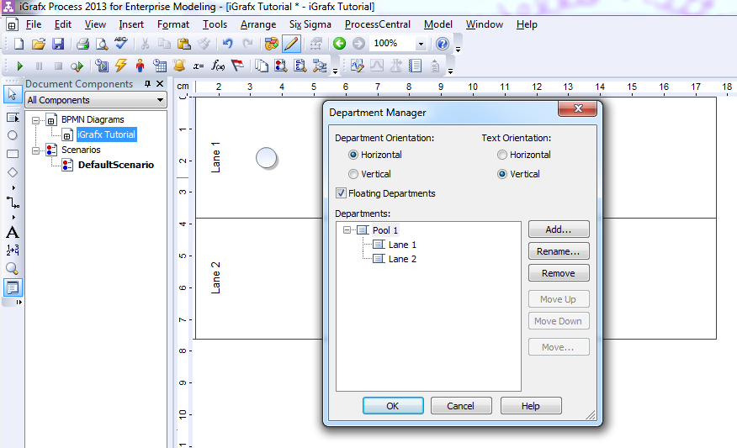
2. A pop-up window “Add Department” will open by clicking on the option “Add”. The new name of the department or the pool is then entered in the field “New Department Name”. Below this is the drop-down menu “Position”. This option will assign positions of hierarchy within the chart. Select the option “Superior” to create a pool for which both lanes 1 and 2 are subordinate.
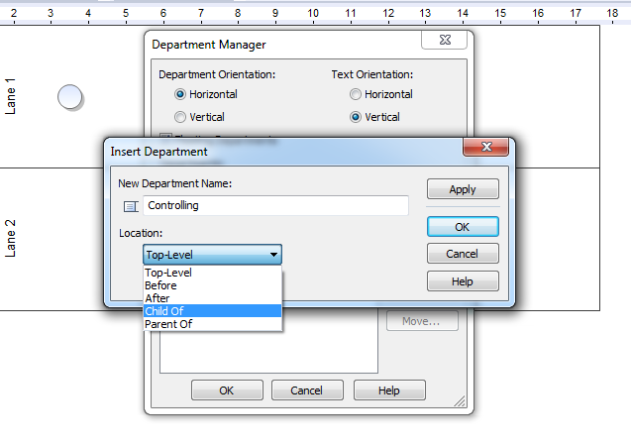
3. In the final step both Swimlanes 1 and 2, which are supposed to be subordinate to the pool, are selected by clicking on them. These entries have to be confirmed by double-clicking on the button “OK”.
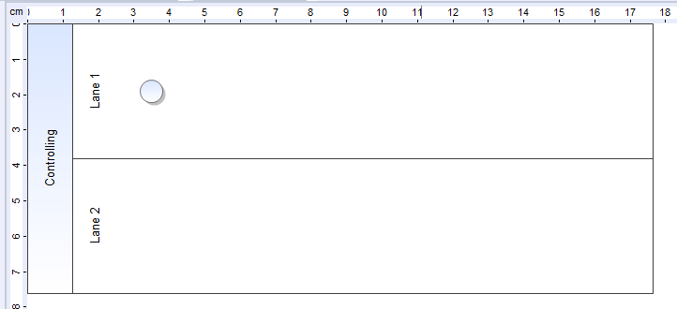

Adding a lane
1. To add a lane to a pool, open the Department Manager. Next, the name and position of the new lane is given. In this context, it is important that a position is selected beneath one of the already existing Swimlanes. Otherwise, the new lane will be added to the chart without getting assigned to a specific pool.
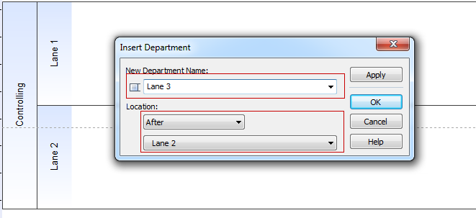
2. The added lane will become visible.
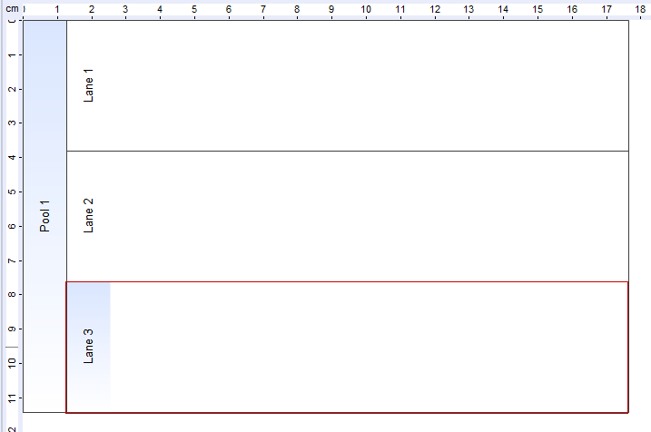
3. If a lane should be added and deliberately remain unassigned to a specific pool, then select “after”, then the corresponding pool in the option “position”. In this case, the new lane will be added beneath the existing pool.
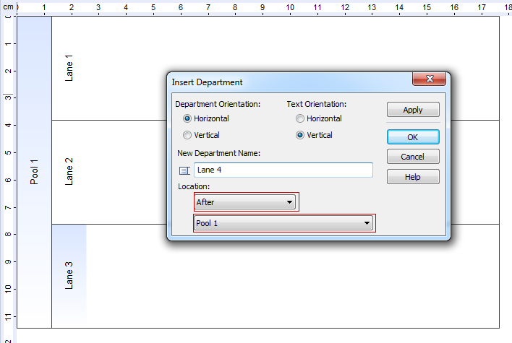
4. Creating a Swimlane that is not assigned to any pool.
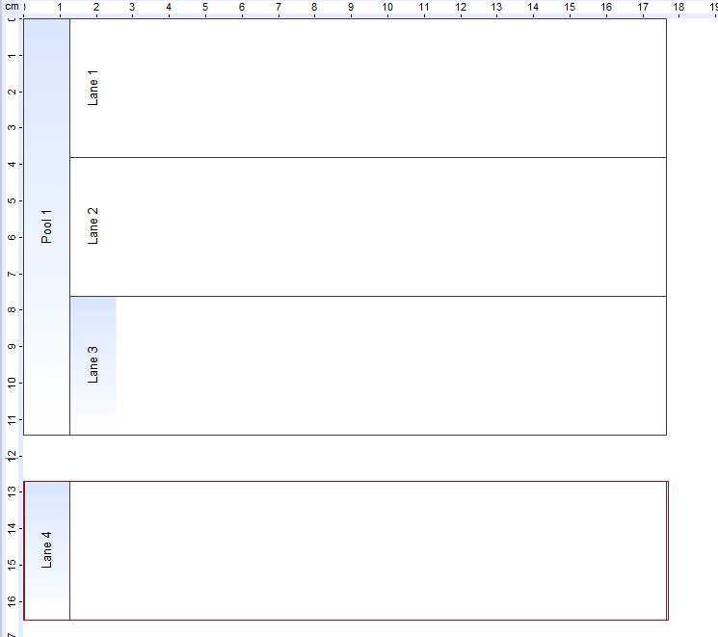

Repositioning Swimlanes within a pool
1. Open the Department Manager, select the Swimlane being relocated and click on “Move Department…”.
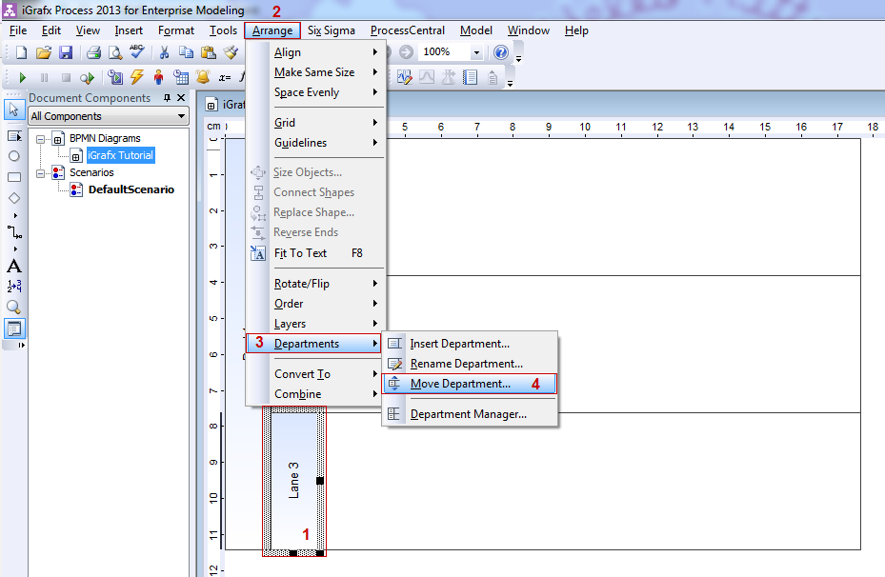
2. The pop-up window “Move Department” will be shown. Here, the new position of the selected lane is given.
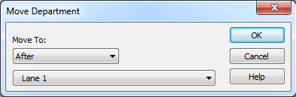
3. By double-clicking on the button “OK” Swimlane 3 has been relocated directly under Swimlane 1.
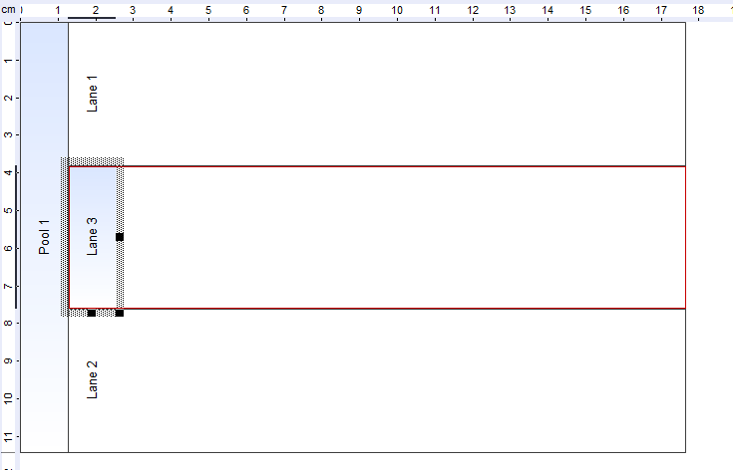

Changing the size of pools and lanes
The size of Pools and Lanes will automatically be adapted according to the content.
If a new element is added, the boundary line will automatically be adapted.

1.6 Opening and saving charts

Opening charts
1. Within igrafx, select File and then Open.
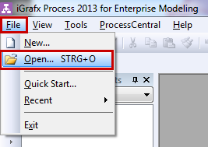
2. An explorer window will open in which all saved process models are shown.
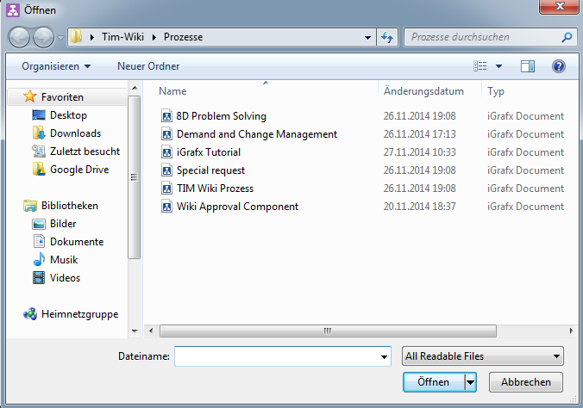
3. Select one of these models and confirm the selection by clicking on Open.

Saving charts
1. Click on File and chose Save.
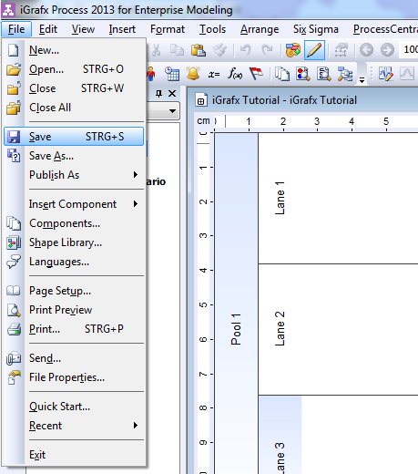
2. An explorer window opens up. Enter a name for this new model and confirm by saving.
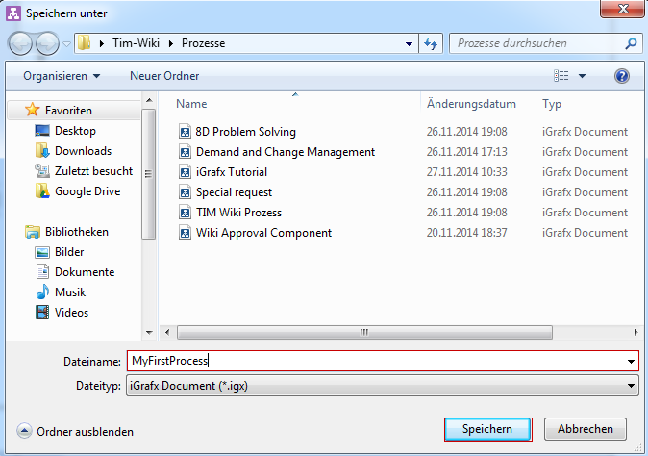

1.7 TIM Attribute/TIM Properties
Elementary attributes which determine the functionality of each element of the process may be assigned. These attributes are called TIM Properties.
The following properties focus on using TIM.

Setting values for attributes by using the Attribute Editor
Elements within a chart often entail many editable attributes. Some of these have an influence on visual representation (e.g. the exact type of loop for specific BPMN tasks), while others do not have any visual influence.
To enter TIM Properties, double-click on an activity. The pop-up window Shape Properties - Activity will appear. Via the last tab “Workflow” the TIM-specific option Execution is accessible.
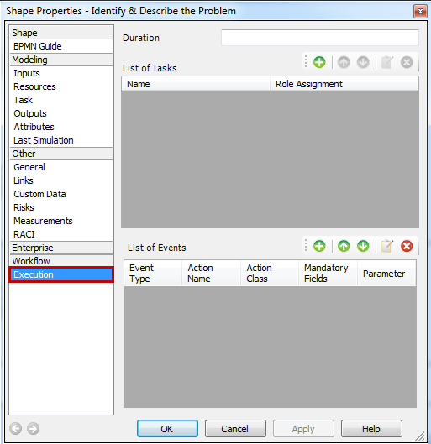
Click on the green highlighted “+” to access the window Edit Task.
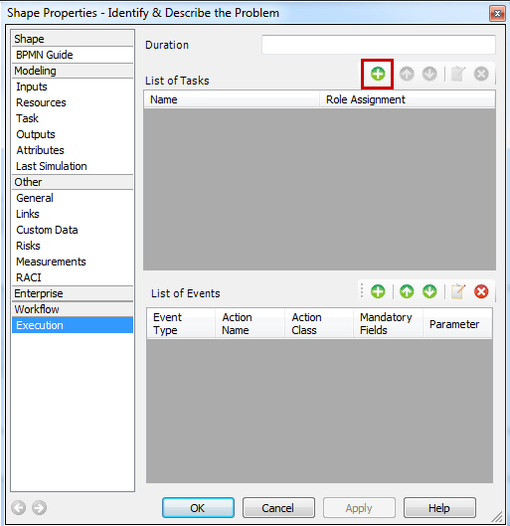
A pop-up window opens in which the task can be edited.
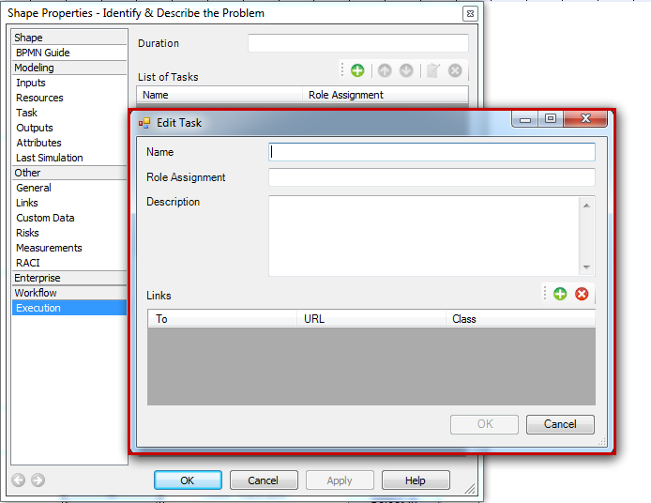
e.g. 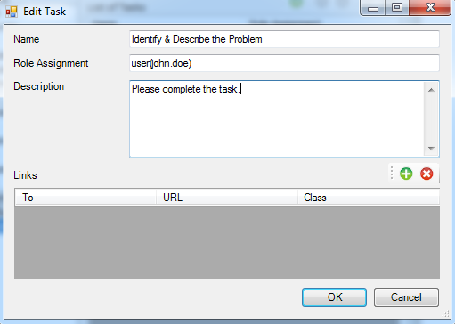

TIM Attribute
The TIM specifications provide access to certain attributes via the Attribute Editor. Nevertheless, only some of these attributes also have visual effects. The following table provides an overview of these attributes.

Attending to the attribute of a starting element
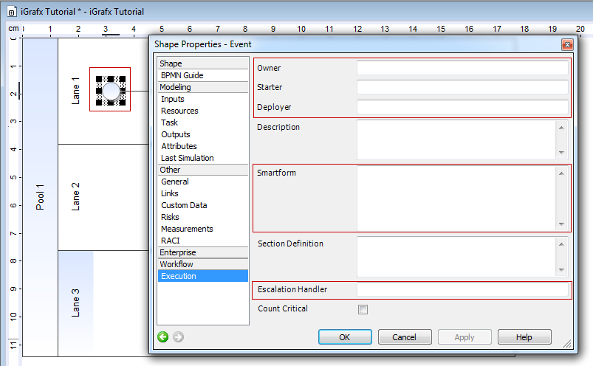
Certain attributes of the starting element of a process need special attention to ensure that a process model will be properly executed by TIM.
Owner MANDATORYFIELD = A user or a group must be entered in this field. This gives the designated user or group the right to own the process in TIM at a later point in time. Multiple groups or users can be added and are separated with a semicolon: “user(a);group(b)” For example: user(john.doe) or group(owner) or all()
Starter MANDATORYFIELD = A user or a group must be entered in this field in order to be eligible to start the process in TIM at a later point in time. Multiple groups or users can be added and are separated with a semicolon: “user(a);group(b)” For example: user(john.doe) or group(starter) or all()
Deployer MANDATORYFIELD = A user or a group must be entered in this field in order to be entitled to deploy the process in TIM. Multiple groups or users can be added and are separated with a semicolon: “user(a);group(b)” For example: user(john.doe) or group(deployer) or all()
Description = Here, a description of the process is entered. This will be shown in TIM
Smartform = The definition of the Smartform should be inserted here
Section Definition = The definition of the section handling should be inserted here
Escalation Handler = An Action Handler can be inserted in this field
Count critical = This option should be selected if the CPM is to be calculated while automating this process
e.g. 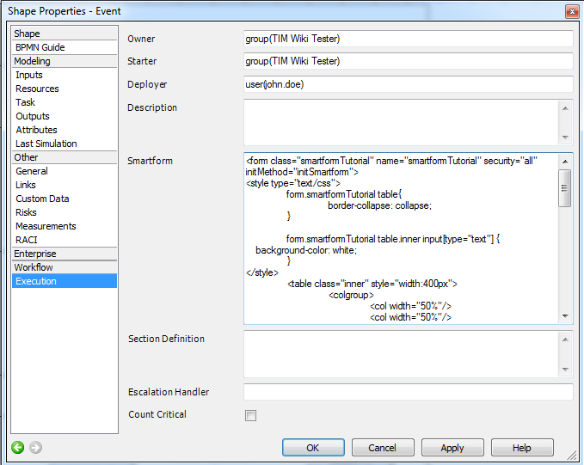

Caring for an Attribute of an activity
Attributes have to be cared for in order to ensure that activities are properly executed in TIM.
Name MANDATORYFIELD = Name of the activity. No special characters are allowed to be used in this field.
Duration = Entries and management of durations. Information on notation: The last two digits represent minutes followed by hours. For example:
30 min = 30
1 h = 60 or 100
8 h = 800
1 Week = 4000 , if 8 hours per day is entered into the calendar profile.
Role Assignment = The role of the executing employee is defined here
Description = A concise description of the task can be provided here
A more detailed description on the topic of activities is provided in chapter II.

Final state
One attribute is assigned to the final state: Ending a completed process

Managing attributes in Pools and Swimlanes
Chapter 1.5 dealt with the topic on how to create and edit Pools and Swimlanes. Related attributes also have to be managed properly to ensure a smooth process. The so-called assignee is the individual employee or the group responsible for executing the tasks of this lane.
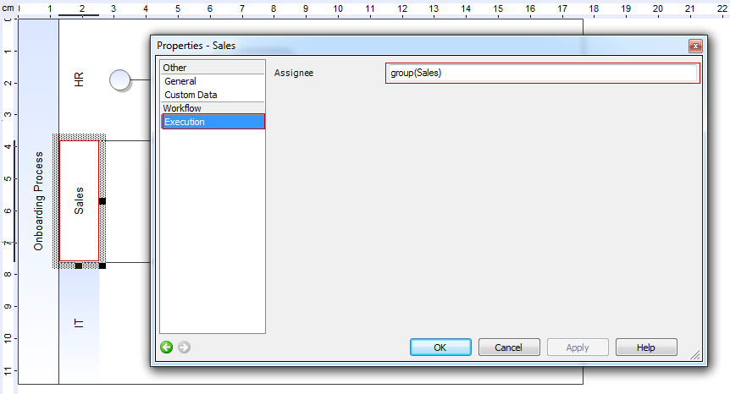

2. Activities and tasks

2.1 Creating activities
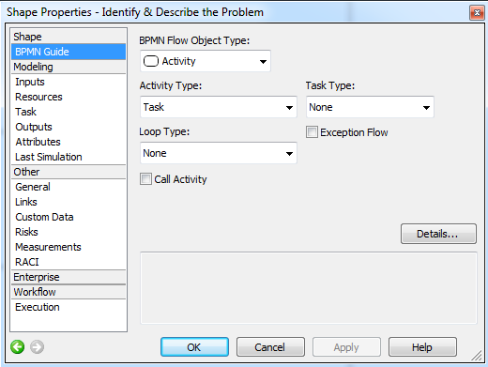
After being positioned, the activity can be described in TIM Properties. The name of the activity has to be well-defined and is not allowed to be used twice for different activities. In addition, special characters are not allowed. The holding time can be entered in the field “Duration” via the window “Shape Properties”.
An activity may but does not have to contain a task. If no task is assigned to an activity, the name of the activity will also appear as the name of the task.

2.2 Creating a new task within an activity
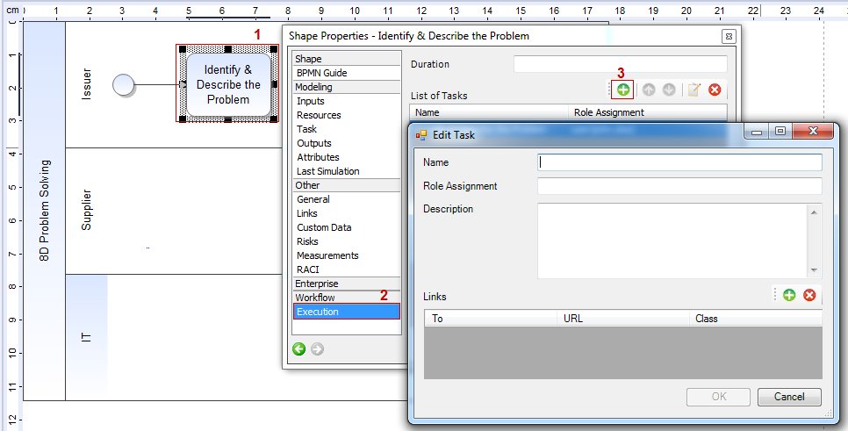
A shortened name for the task has to be entered in the field Name which will later be used in messages.
Role Assignment is an aid used to assign tasks to employees. Groups or users can directly be entered in this field. This option has the possibility to assign a task independently from the automatic swimlane assignment
Groups have to be entered using this syntax: group(Name_of_Group)
To indicate the identity of the editor the following syntax has to be used: user(Name_of_Editor)
Description provides a detailed description of a specific task to the person responsible for modelling. For example, text elements from procedural instructions can simply be copied and pasted into this field.
Links can easily be collected by using the option Links.

3. AND, XOR and OR

3.1 AND relation
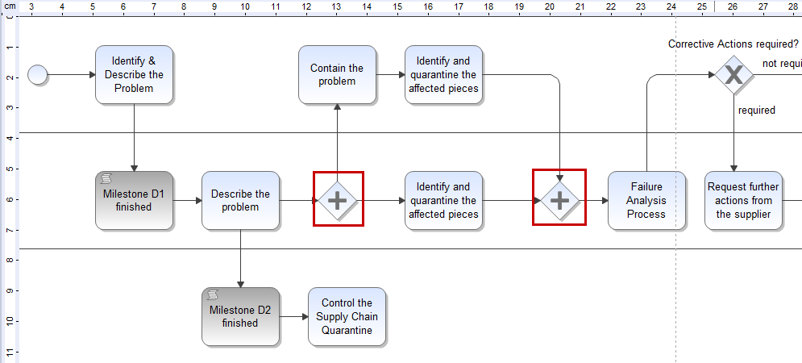
In the case of an “AND” relation between several distinct activities all tasks have to be done before this “AND” relation can be exited and the process can move on to the next task. For this to be successfully accomplished, activities have to be located between two “AND” functions. These have to be connected by using transitions as described above in an earlier section.

3.2 XOR as an exclusive "or"

Human XOR gateway
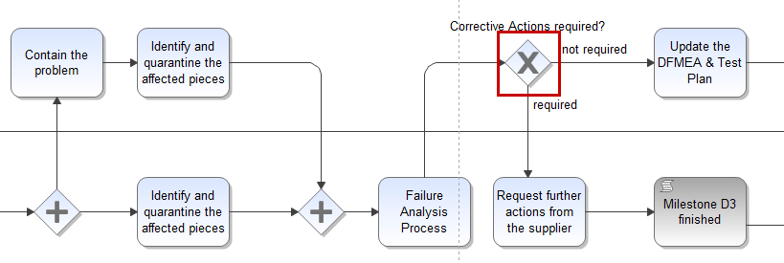
In the case of a XOR gateway, transitions will be directly linked to alternative activities (i.e. the user has to decide which specific activity to choose). At a later stage the user will receive access to a related selection via a pop-up window. This will enables users to manually select the pathway themselves.
These decisions will be shown within the TIM pop-up window. They will be shown according to the specific order assigned to them as a result of the previously created XOR gateways of the process modelling stage.

4. Endings

4.1 Completely Terminating Ending
If you use a “Completely Terminating Ending” (Terminate Event in the Shape Library), it will upon arrving at that ending terminate the whole process.


4.2 Partially Terminating Ending
A “Partially Terminating Ending” can be used in the model by inserting a Generic Event and the drawing an arrow from an Activity to it.
Once you arrive at a “Small Ending” it will not terminate the whole event, but rather just one way. This way you can terminate one “Way” of an AND Gateway, but the process will still continue.
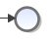

5. Mail nodes

5.1 Mail node
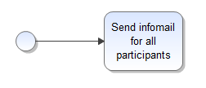
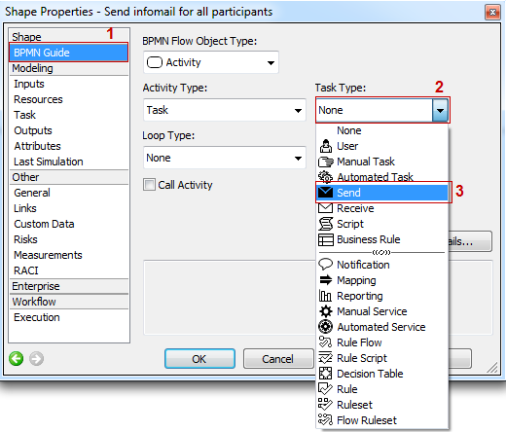
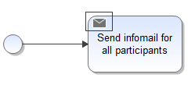
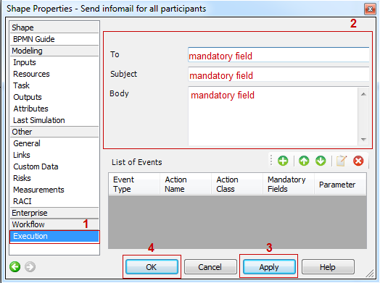
The mail node is an easy-to-use functionality, which allows the user to send standardized e-mails with TIM. These e-mails may entail messages to contact external individuals and groups as well as participants of the process and relevant decision makers. The e-mails may contain information on the process itself or reminders to execute tasks in TIM.
To integrate an e-mail into a given process, simply position and name a new activity in the process model.
At this stage in the process, the activity has to be transformed into a mail node using the option in the symbol properties. By double-clicking on the activity, the property menu is opened and the tab BPMN guide is selected. Within the red colored area the setting related to the type of task has to be changed from “none” to “send”.
In the upper left-hand corner of the activity symbol a small envelope-icon will appear to indicate that the mail node has been activated.
In the next step, the property window is reopened to determine the correct addressee, the subject heading and the actual textual content of the e-mail. This is done within the attribute settings. Next, the tab labeled Execution is selected and the entries are finished.
The action is then confirmed by clicking on “Apply” followed by “OK”.

6. Deployment and links

6.1 Debugging and deployment

Debugging
Prior to making a process publicly accessible, a debugging process has to be conducted; this is the so-called Deployment Check. The BPMN chart type offers the possibility to conduct specialized real-time error checks. These are meant to ensure that every chart meets the specifications of the BPMN-standard. This procedure in turn guarantees that each chart is exportable and executable with TIM. These kind of real-time error checks are automatically done during the modelling stage. This guarantees that the modeling process always conforms to the BPMN-standard.
To find additional errors in the BPMN chart or to check a process for possible errors, the following steps are provided:
1. Select the option “Check” in the menu “Model”:
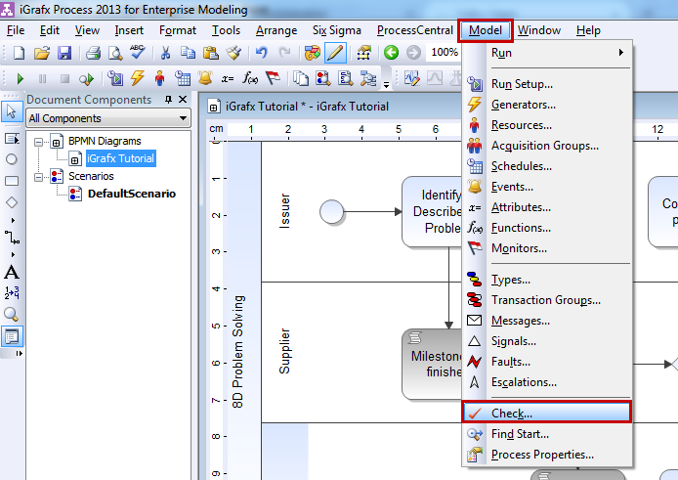
The dialog field will be opened:
Now a test can be conducted to see if the current chart, all charts within the document, or the whole model as such is only simulated or additionally compatible with/exportable to TIM.
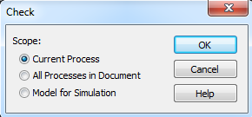
2. Select the option Current Process and click on the button OK to start checking for any errors.
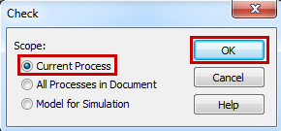
The output display at the bottom of the screen will then indicate if there are any warnings or if the process model runs smoothly without any errors.
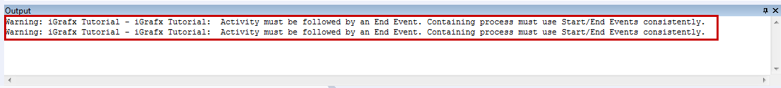
3. By double-clicking on a warning report in the output display the symbol, which is the source of the error, will be highlighted.

Deployment Check
A so-called “Deployment Check” should be conducted before a process model is set to be published or deployed. This will ensure that all necessary attributes are maintained, that each activity is clearly labeled, that all transactions are terminated, and that the process does not have any loose ends on the agenda.
To start a Deployment Check, select “Validate Workflow” within the menu item “Tools”.
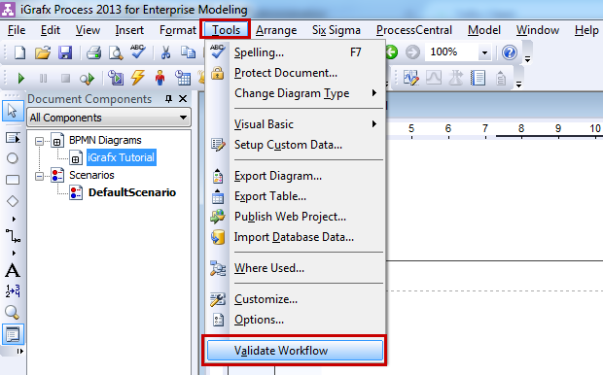
Error messages, together with related short descriptions, are shown in the output display at the bottom of the screen:
the corrupted element is selected for further editing by double-clicking on the error message in the output display.
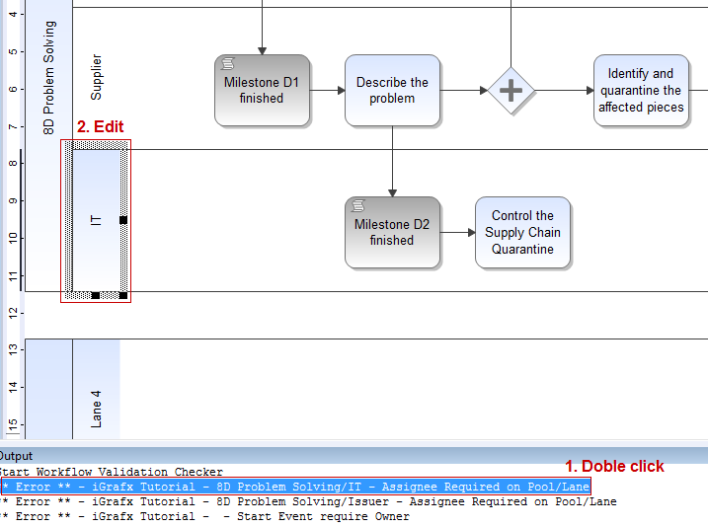

Deployment/exporting by using the iGrafx4TIM plugin
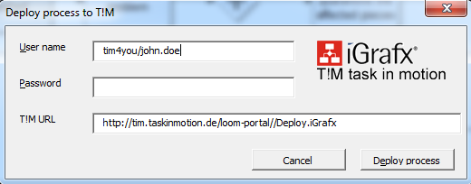
To publish or deploy a process in TIM, select Publish As via the menu item File and then “Workflow Deployment”. To successfully conduct the deployment procedure, the user must be assigned the role of deployer in the TIM administration.
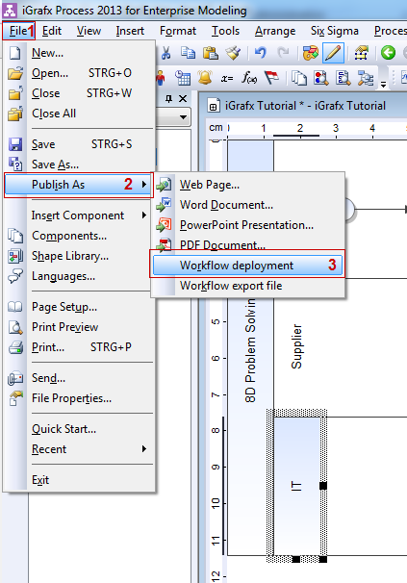
To deploy a process, the user log-in of the user with deployment capabilities is required (login name and the password).
The following attributes constitute the address of deployment:
http://show.taskinmotion.de/loom-portal/Deploy.iGrafx
- http://show.taskinmotion.de/ (Name of the server)
- loom-portal/ (Name of the destination folder)
- Deploy.iGrafx (This indicates the status as a deployment and to which modelling tool the process of deployment belongs to)
 | ATTENTION: Subprocesses have to be saved in their own separate file! The first step in the deployment procedure is the deployment of all subprocesses. The second step is then the actual deployment of the main process. This procedure also applies when changes have to made to the subprocess!

6.2 Links
Links may be added while creating a task for an activity. These links will be shown to the designated user assigned to complete this task.
A link may be created by clicking on the green “+” symbol.
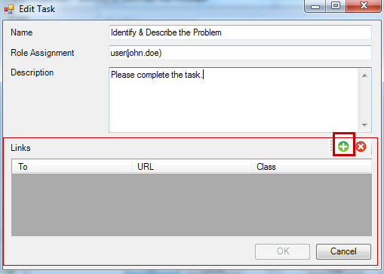
To implement a link with iGrafx the following parameters have to be entered:
- To : The link can be given a distinct name in this field
- URL : Here an address as a point of destination in the internet or intranet has to be entered.
- Class : Two different classes are available for selection:

com.dooris.bpm.entities.SimpleUrl
This class has to be used if the link is not subject to parameterization

com.dooris.bpm.links.ProcessVariableLink
This class is selected if process variables are supposed to be implemented within the link.

A fully detailed step-by-step description is available in the section on how to implement links.

7. Subprocess

7.1 Main process and subprocess
Processes may have hierarchical structures. Because of this, a main process could be divided in several subprocesses. This is advantageous, if for example the main process is large and confusing. Redundancies should be avoided and parallel sections of subprocesses should be consolidated. Subprocesses have the same structure as main processes; they need a start- and an end event. Process owner, -starter and -deployer as well as assignees have to be selected for the swimlanes.

7.2 From main process into the subprocess
To move from the main process further into the subprocess it is necessary to set the activity type of the activity that starts the subprocess to “Collapsed Subprocess”. This is done by clicking twice on the activity / BPMN Guide / Activity Type. The subprocesses have to be named correctly on the tab “Automation”. In order to rename the subprocess, select it with the mouse.
ATTENTION : A new file has to be created for every subprocess! First of all, all subprocesses have to deployed; afterwards, the main process may be deployed. Even if there were only some small changes in the subprocess, it is important to deploy the subprocess before the main process.
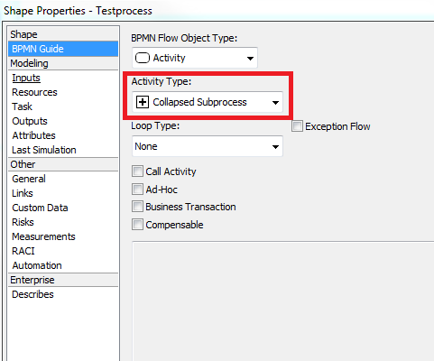
The activity gets a small plus as a symbol.
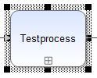
Once the main process has reached the activity with the “Collapsed Subprocess”, the subprocess begins. The main process waits on this position until the end of the subprocess is reached. Afterwards, the main process is resumed.

7.3 Creating and passing variables
In order to create new variables for the main- & subprocess, new parameters on the activity of the “Collapsed Subprocess” must also be created. First, double-click on the activity. A green plus is found on the tab Automation/Parameters. New variables, which may be named at will, are created by clicking on it. Additionally the variable can receive the capability to read & write.
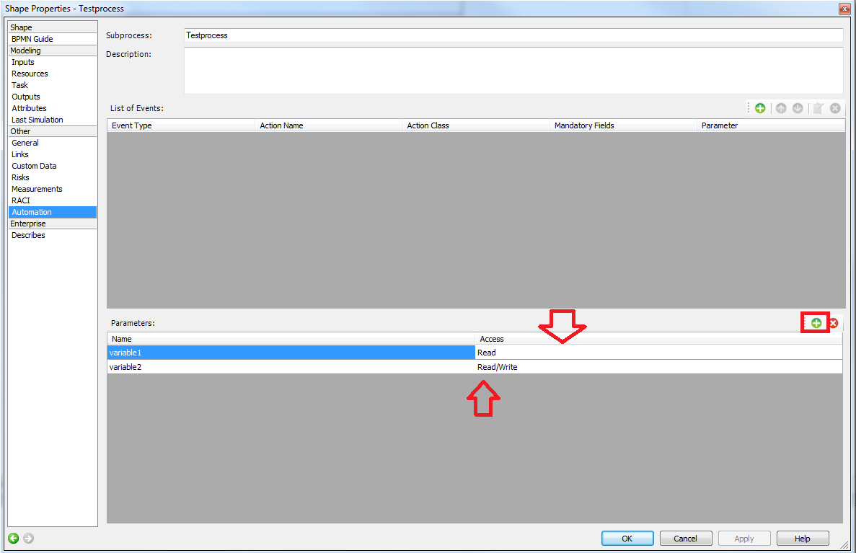
The difference:
If “read” is selected while passing the variables, the variables will be passed into the subprocess but not written back into the main process. If “read” and “write” are both selected while passing the variables, the variables will be passed into the subprocess and written back into the main process (and eventually overwritten, if the value changed in the subprocess).
e.g.
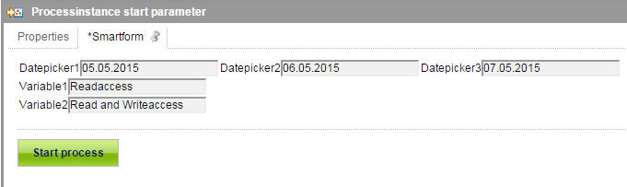image detail 1.1 smartform before process start
Process start: value of Variable1 is: Readaccess value of Variable 2 is Read and Writeaccess.(image detail 1.1)
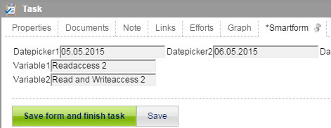image 1.2 after changing the value of the variables
In the subprocess, the values were changed in the smartform. Value of variable1 : Readaccess2 Value of Variable2 : Read and Writeaccess2 (image detail 1.2)
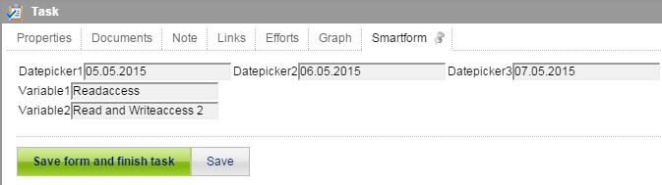image detail 1.3 Smartform of the main process after reaching the end of the subprocess.
After terminating the subprocess only Variable2 was written back in the main process because “read-” and “write” access were selected. Variable 1 had only read access so it did not change in the main process (image detail 1.3).

