RenameInstanceHandler

Description
This handler renames the current instance by any text that can include variables.

Action Class
com.dooris.bpm.actionhandler.RenameInstanceHandler

Event Type
any type

Action Name
any name

Mandatory Fields
-

Parameter

instanceName = desired_name_${variable}
Variables are specified as ${variablename} (see Example)

A continuous ID for process instances
The system variable ${SYS.BUSINESS_ID generates a unique, continuous ID for every created process instance. The system variable can be used in the renameInstanceHandler. Thus, every created process instance is given a unique, continous ID.
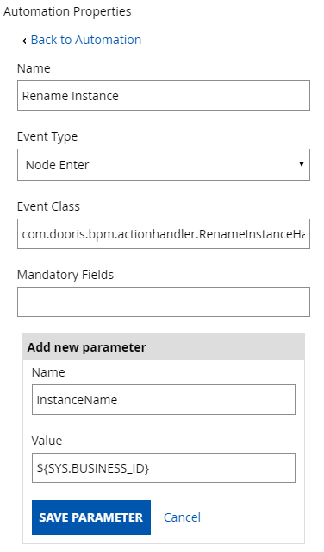

Example


